**Professor Richard Reeve** 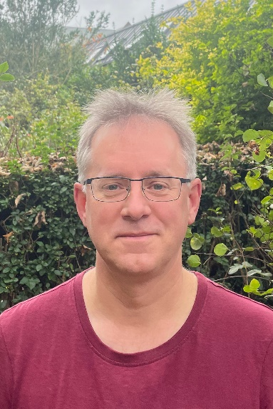

**Trade Union Member**

Richard Reeve is President of the University of Glasgow branch of the University and College Union (UCUG) and the Professor of Population and Ecosystem Health in the School of Biodiversity, One Health and Veterinary Medicine at the University of Glasgow. He graduated from the Universities of Cambridge (MA in Mathematics) and Edinburgh (MSc in Computing, PhD in Artificial Intelligence, PGDE in Secondary Education), and subsequently worked at the Universities of Stirling, Zurich, Edinburgh and now Glasgow.

He was one of the first contract research staff representatives at the Universities of Stirling and Edinburgh for UCU’s predecessor union, AUT, over 20 years ago, and casualisation and working conditions remain his primary concern in UCU. He was also the Edinburgh AUT lead for negotiations on the move to the single pay spine in 2005, and he jointly leads similar negotiations now (on pay and grading) at Glasgow. As well as Court, he also sits on the University’s Joint Committee for Consultation and Negotiation, the Extended Workforce Policy Oversight Group (which oversees policy on casualised staff), and the Joint Union Liaison Committee.

Within the University, he helped set up the first Research Software Engineering Group at the University in the College of Medical Veterinary and Life Sciences (MVLS), and he now helps to oversee this as part of MVLS’s Research Computing Steering Group. He is also on the University’s Research Computing as a Service (RCaaS) Steering Group, which oversees the newer analogous University-level RCaaS group. He is also a founder member and current co-director of the Boyd Orr Centre for Population and Ecosystem Health, a cross-disciplinary research centre based at the University that won the Queen’s Anniversary Prize in 2013.

Academically, he is an ecological modeller. He led FAO’s HQ Expert Group on predictors of protection for foot-and-mouth disease and was an expert advisor to WHO’s Global Influenza Surveillance and Response System for determining seasonal flu vaccine composition until 2020; he jointly led the Scottish COVID-19 Response Consortium during the pandemic; and he is currently a Senior Expert for NERC’s Constructing a Digital Environment Programme where he works on the impact of climate and land use change on global biodiversity.