Staff Equality Monitoring Report 2021-22

Executive Summary

This is the eleventh annual staff equality monitoring report produced by the Equality and Diversity Unit and follows largely the same format as the previous reports to allow comparison between years. This report supports the University’s obligations to publish annual staff equality monitoring data as part of the Public Sector Equality Duty (PSED) under the Equality Act 2010.

The publishing cycle reflects the previous academic cycle (August 2021 –July 2022).

The report shows the following important points, changes and challenges:
- Since 2018-19, our colleague community has increased by 15%.
- The KPI’s set in the University strategy has three diversity components, the variance this year are:
  - Senior women have had a minor decrease from 33.2% to 32.8%.
  - Declared disability has increased from 4.9% to 5.3%.
  - UK Black, Asian and Minority Ethnic (BAME) representation from 4.5% to 4.9%.
- The University’s percentage of International staff continues to grow, up 2.2% since 2020-21 and 4% since 2018-19.
- The percentage of all Black, Asian or Minority Ethnic (BAME) colleagues has increased 2% from 2020-21 to 11.6%.
- The largest cohort of colleagues who have a recognised faith are Christian at 16.8%, with Roman Catholic being the largest contingent at 7.5%.
- The University’s Lesbian, Gay and Bisexual (LGB) community declaration rates continues to grow, with an increase of 1.6% to 5.5% this year. The highest increase of 1.5% is seen in Science and Engineering. The largest proportion are Grade 3 at 11.4%.
- For colleagues who identified as a different gender to that registered at birth continues to grow, with an increase of 30% since 2020-21, however the numbers are small.
- Both Operational and Technical & Specialist job families are moving towards a bell curve of age ranges, bucking trends of an older and younger cohort respectively.
- Disability declarations have increased across most grades, notably in Grade 3 with a 3.1% increase.
- There are large cohorts of ‘Unknown’ Disability declarations in contract types S and F.
- The percentages of BAME colleagues have increased across all grades and Colleges/University Services(US), with Science and Engineering having the biggest rise; up 3.5% to 18.8%.
- There continues to be significant disproportionate percentages of BAME applications compared to successful applicants across job families, reinforcing the importance of the Understanding Racism, Transforming University Cultures (URTUC) action relating to this.
- Science and Engineering have seen a 1.2% drop in female colleagues. However, across job families females are more successful than males in relation to recruitment.
- Case management has small numbers, but females are more likely to go through Managing Attendance and Grievance, the latter with an increase of 24.1% from 2020-21; males are more likely to go through Disciplinary.
- 16.3% of those going through Managing Attendance have declared a Disability, compared to 5.3% of the University colleague community.

Introduction

The Staff Equality Monitoring Report allows the University to have a standard base for all staff equality information across the organisation. This report meets one of the University’s obligations under the Public Sector Equality Duty (PSED).

The aim of this report is to provide transparent data for all functions in the institution to use when equality information is required, such as when conducting Equality Impact Assessments (EIA).

Structure

This report has been structured to provide a ‘Whole University’ overview by all the main protected characteristics plus full/part time working, and maternity leave followed by specific sections on Age, Disability, Ethnicity, Sex and Sexual Orientation with a breakdown of data by the following:
- College
- Grade 10 staff
- Job Family Profiles
- Grade
- Full/Part Time
- Contract Type
- Nationality
- Recruitment – by all applicants and successful applicants

We have not provided a further breakdown beyond ‘Whole University’ on data for religion and belief as the proportion of staff answering these questions is too small to give meaningful information.

Further information has then been provided on:
- Academic Promotions – by Sex
- Regrading for Professional & Support Staff – by Sex
- Case management - by Sex, Ethnicity and Disability
- Sickness Absences - by Age, Disability, Ethnicity, Sex, and Sexual Orientation

Notes and definitions

This report is based on a census date of 31 July 2022, unless otherwise stated. This date captures staff at their grade prior to any promotions which take effect on 1 August. Percentages have been provided, as there are some instances where numbers are very small and using actual numbers carries the potential to be able to identify individual staff. Overall proportions for each of the sections have been provided in Tables 1-6 below.

Whole University - Total head count is 9595 (up 215 on last year). This is the head count for all staff in the University; those with multiple contracts are only counted once. The three previous year’s total headcount figures were 8198 (2018-19) and 8691 (2019-20) and 9380 (2020-21).
College/University Services Split
When using the term ‘By College’ later in this report University Services is also included.

Table 1 - College | %2019-20 | %2020-21 | %2021-22
Arts | 8.3% | 7.9% | 8.5%
MVLS | 30.2% | 32.9% | 29.4%
Science and Engineering | 19.7% | 19.5% | 21.8%
Social Sciences | 14.8% | 15.7% | 16.7%
University Services | 27.0% | 24.0% | 23.6%

Job Family Profile
Some members of the Senior Management Group (SMG) may be classed as ‘Research & Teaching’ or ‘Clinical’ under the Job Family profile. For reporting purposes, they will have been moved into SMG, and the original Job Family figures amended accordingly.

Table 2 - Job Family | %2019-20 | %2020-21 | %2021-22
Clinical | 3.4% | 3.3% | 3.3%
Management, Professional and Administrative (MPA) | 28.2% | 27.5% | 27.5%
Operational | 9.9% | 8.3% | 7.8%
Research & Teaching | 48.5% | 47.4% | 52.9%
Senior Management Group (SMG) | 0.2% | 0.2% | 0.1%
Technical & Specialist | 9.8% | 13.4% | 8.4%

By Full/Part Time
All staff who work less than one FTE are considered Part Time.

Table 3 - Full Time / Part Time | %2019-20 | %2020-21 | %2021-22
Full Time = FTE 1.0 | 63.6% | 65.5% | 63.5%
Part Time = FTE - 0 + anything < 1.0 | 36.4% | 34.5% | 36.5%

By Contract Type
The contract types are as follows;
F = Fixed term as per FT & OE Contract policy
O = Open ended with funding end date
P = Open ended + Permanent in Temporary Fixed Term Appointment
S = Fixed term - SOSR e.g. Maternity leave cover

Table 4 - Contract Type | %2019-20 | %2020-21 | %2021-22
F = (F) Fixed term | 22.8% | 29.1% | 20.8%
O = (O) Open ended with funding end date | 17.4% | 15.6% | 14.6%
P = (P) Open ended + (C) Permanent in Temporary Fixed Term Appointment (Head of College/Principal/Vice Principal roles etc.) | 58.7% | 54.2% | 56.1%
S = (S) Fixed term - SOSR e.g. Maternity leave cover | 1.2% | 1.1% | 8.5%
In the last year the University has moved some colleagues from Fixed term contracts to SOSR contracts, these have in the main part been GTAs, Tutors and Demonstrators. This is reflected in the decrease in Fixed Term contracts and the increase in SOSR contracts since 2020-21 to 2021-22.
Grade Grouping
Table 5 - Grade Grouping | % 2019-20 | % 2020-21 | % 2021-22
Grade 1 | 4.1% | 2.5% | 1.6%
Grade 2 | 3.9% | 4.2% | 3.8%
Grade 3 | 4.7% | 6.0% | 4.2%
Grade 4 | 4.9% | 4.9% | 5.6%
Grade 5 | 14.8% | 15.7% | 14.6%
Grade 6 | 18.4% | 19.6% | 20.7%
Grade 7 | 17.1% | 16.6% | 17.7%
Grade 8 | 12.8% | 12.5% | 12.9%
Grade 9 | 8.1% | 7.6% | 8.1%
Grade 10 (see Table 6 for definition) | 7.4% | 6.7% | 6.9%
Clinical | 3.5% | 3.3% | 3.3%
Other | 0.4% | 0.5% | 0.5%

Table 6 – Grade 10 staff  (based on Actual Grade Description) | % 2019-20 | % 2020-21 | % 2021-22
Professor & Equivalent MRC Grades | 88.5% | 88.6% | 88.5%
Senior Administrative Group | 9.3% | 8.9% | 9.4%
Senior Management Group (SMG) | 2.2% | 2.5% | 2.1%

Age
Two charts are provided for the whole University age data, using 5-year groupings and then 10-year age groupings. For all subsequent charts, the age data is provided using the 10-year age groupings only.

Disability
Two charts have been provided for the whole University disability data, whether staff have stated they have a disability, and then by impairment category. For all subsequent charts the disability data is only provided by whether staff have stated they have a disability or not. Disability statistics include colleagues who have self-identified as ‘disabled’, as well as those who have provided details of an impairment or long-term health condition, whether they have self-identified as ‘disabled’ or not.

Ethnicity
Two charts have been provided for the whole University ethnicity data. For all subsequent charts all ethnic minority categories have been combined into Black, Asian or Minority Ethnic (BAME).

The nomenclature Black, Asian and Minority Ethnic (BAME) was introduced in the 2016-17 report as agreed at the time by members of the University’s Race Equality Group. The University understands this is not a collective experience, however as numbers are small we cannot currently present the data in smaller subsets.

Maternity
This outlines the percentage who returned to work, the percentage still on leave and due to return, those whose contract ended within the period and those who resigned within the reporting period.
Gender Reassignment
In order to collect information in relation the protected characteristic of gender reassignment the University currently uses the 2021-22 HESA recommended question ‘Does your gender identity match your sex as registered at birth?'. Responses are based on the staff member’s own self-assessment. Due to the wording of the HESA recommended question, it is possible people who identify as Non-binary may be included in the statistics.

Nationality
This is based on information provided by staff about their right to work in the UK. For the purpose of this report, we have used the following categories: UK, EU/EEA and International.

Sexual Orientation
For the purposes of this report, the sexual orientation categories of Lesbian, Gay and Bisexual have been combined and shown as LGB. The whole University data shows the full breakdown, including where information has not been declared. Due to high undeclared rates, all subsequent charts only rates of declared sexual orientation or ‘prefer not to say’ data is provided.

Recruitment - Applications and Successful Applicants
The census date is based on the date the post was first advertised, 01 August 2021 – 31 July 2022. The information excludes direct appointments. The data will include someone more than once if they applied for multiple roles during the time period. Some roles have more than one post available and so have more than one successful applicant. Data is provided for applicants and successful applicants. The data excludes those who withdrew during the application process or prior to an offer decision.

We continue to have high numbers of instances where we receive no monitoring data from applicants; this is recorded as ‘Unknown’ in the data set. We will work with the University’s Recruitment Team to understand the causes and engage with them to seek and implement solutions to minimise this in the future.

Case Management
This section provides data on formal employment related procedures - Managing Attendance (previously known as Capability), Discipline and Grievance cases during the report period
01 August 2021 – 31 July 2022. Data is provided by Sex, Disability and Ethnicity. Grievance case numbers are based on the staff member who raised the Grievance.

Additionally, within this section data is provided on Sickness Absences between 01 August 2021 –
31 July 2022. Figures are based on those staff who had at least one absence of 20 or more continuous working days. Charts are provided by Age, Disability, Ethnicity, Sex and Sexual Orientation.

Academic Promotions and Professional & Support Staff Regrading
The data for promotion is only provided by Sex as further disaggregation carries a risk of identifying individual staff.

Pay Gap Information
In accordance with the Public Sector Equality Duties, the Gender Pay Gap and Equal Pay information for Disability and Ethnicity are provided in line with our legislative requirements in a separate report.

Whole University Profile

Age

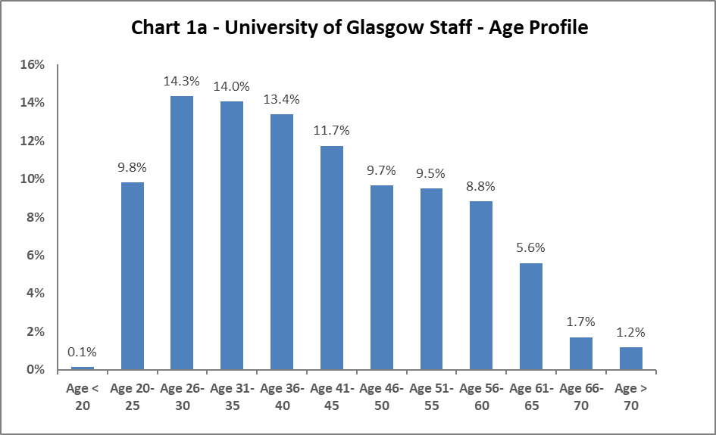

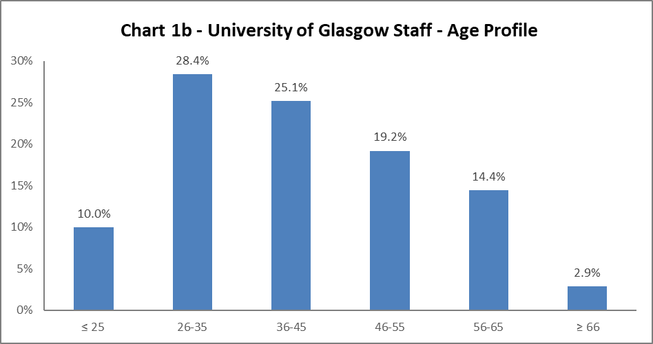

The University's age profile changed during 2020-21, and this is mirrored in 2021-22. The University colleague age profile continues to be younger, usurping the previous trends of a bell curve. There are small fluctuations between this year and 2020-21, however these are minor.

Disability

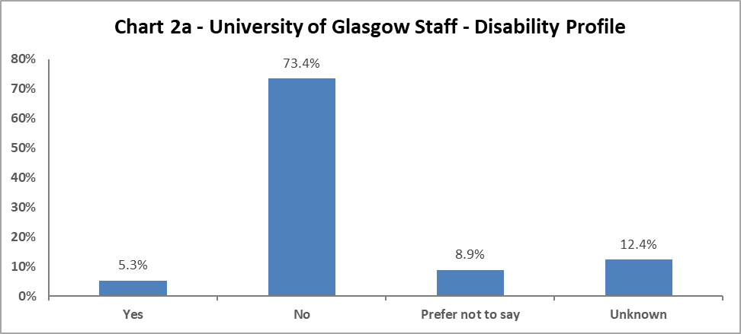

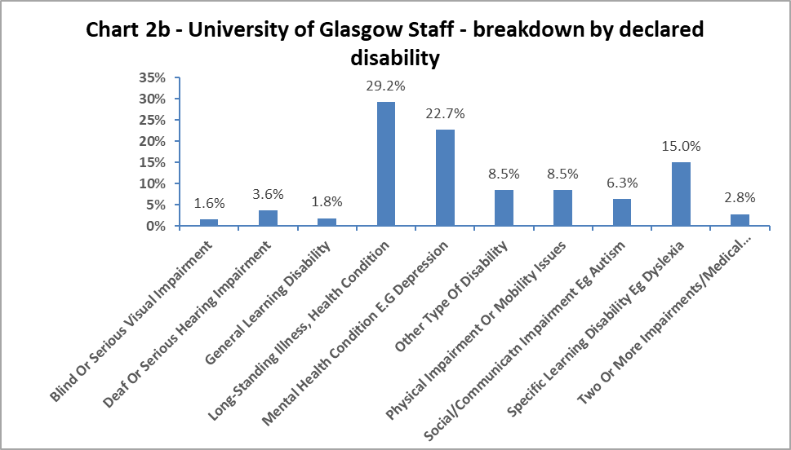

Chart 2a above shows 5.3% of colleagues have declared a disability, this is a 0.9% increase since 2019-20. In addition, there has been a 1.9% decrease in colleagues stating, ‘Prefer not to say’, which is the reverse of the rise in 2020-21. The ‘Unknown’ category has risen by 1.2% since 2020-21. The data implies colleagues continue to gain confidence in the University’s recording systems.

When considering impairment type, in Chart 2b, the largest cohort of staff has a longstanding illness or health condition, has increased marginally from 2020-21 by 0.2%. The next highest category is colleagues with a mental health condition, though this has decreased by 2.2%. For other impairments, the data shows there has been an increase of 1.6% in colleagues with a specific learning disability, a 1.1% increase with a social/communication impairment (such as autism) and a decrease by 1.2% in colleagues with a physical impairment or mobility issues since 2020-21.

Marital Status

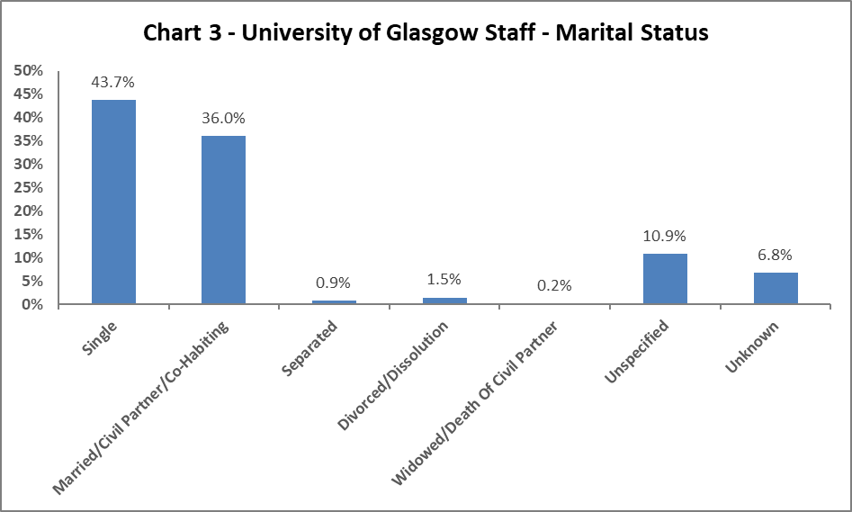

Chart 3 shows the largest percentage of colleagues are single, however this is a 3.4% drop since 2020-21. All other martial status areas have seen minor fluctuations, with the exception of ‘Unknown’, which has grown by 4.3% since 2020-21.

Full Time/Part Time

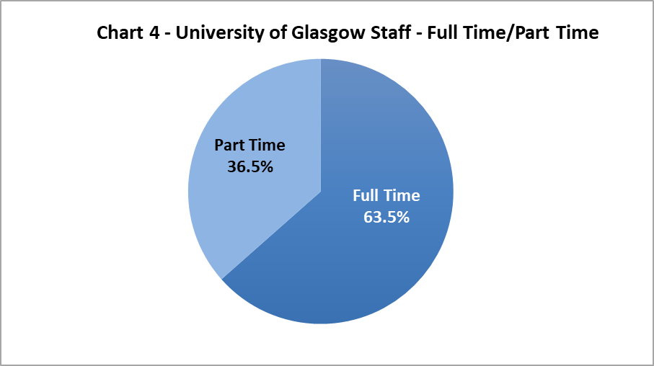

Chart 4 shows approximately two thirds of colleagues work full time and one third work on a part time basis. Part Time staff have increased by 2% since 2020-21, reversing the drop seen in 2019-20.

Nationality

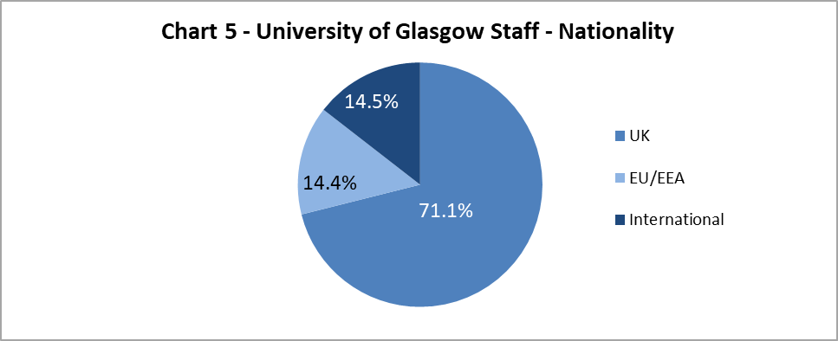

The data shows a 2.2% increase in colleagues from International backgrounds since 2020-21, which is a 4% increase since 2018-19. The proportion of EU/EAA colleagues has stayed static since 2020-21 and UK colleagues have reduced by 2.5%.

Ethnicity

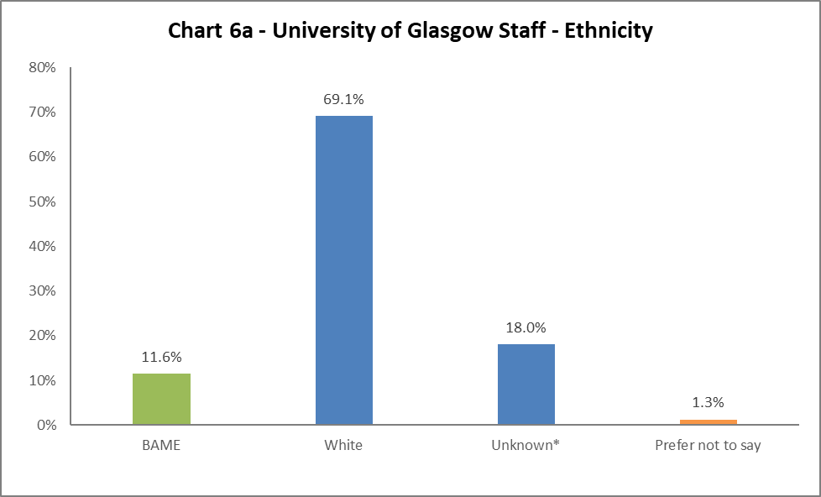
Chart 6a shows 11.6% of colleagues are from a Black, Asian or Minority Ethnic (BAME) background, an increase of 2% from 2020-21. There has been a 1.5% decrease of colleagues from White backgrounds. There has been a 0.8% decrease in ‘Unknown’. The full ethnic breakdown is provided in Chart 6b on the next page.
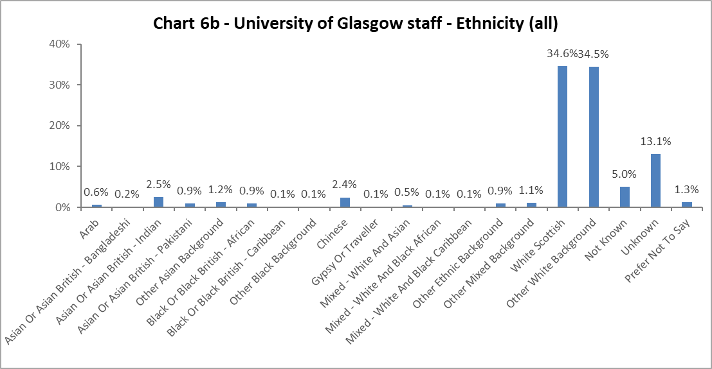

Religion and Belief

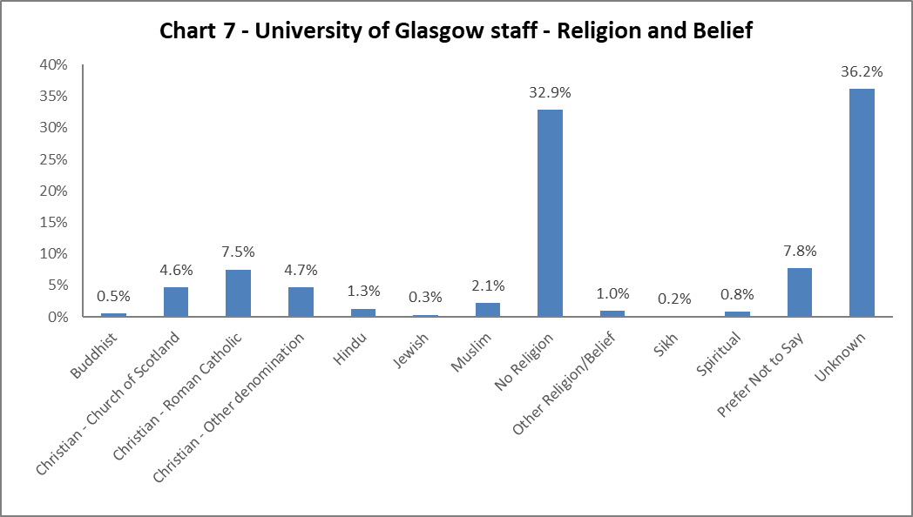
The largest component of declared colleagues continue to state they have no religion, an increase of 1.1% from 2020-21. 16.8% of colleagues state they are Christian, of which the largest proportion are Roman Catholic (7.5% and increased 0.3% from 2020-21). There has been a slight rise in Hindu, Muslim and Spiritual colleagues, by 0.4%, 0.3% and 0.6% respectively since 2020-21. All other faiths have seen minor fluctuations.

Sex
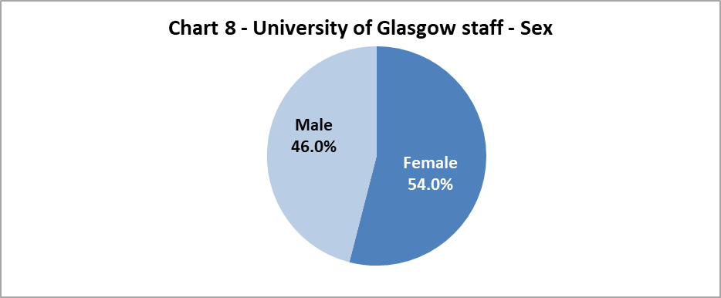

Chart 8 shows the proportion of colleagues by Sex, this only changed by 0.3% between the sexes from 2020-21.

Sexual Orientation

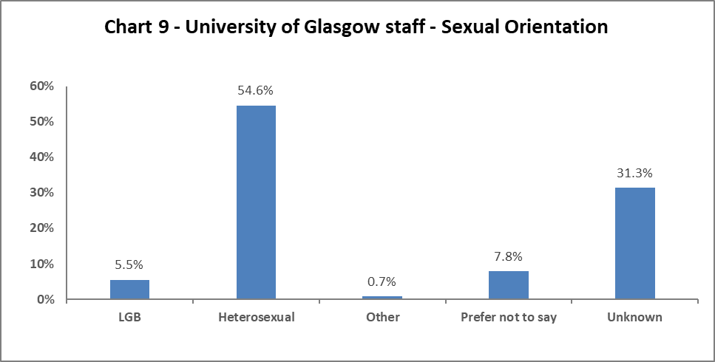

Chart 9 shows the percentage of colleagues who identify as Lesbian, Gay or Bisexual – this has increased to 5.5%. This is a 1.6% increase since 2018-19. There have only been minor fluctuations in the other sexual orientation categories, but notably a 1% decrease in colleagues stating the ‘Prefer not to say’.

Maternity Leave

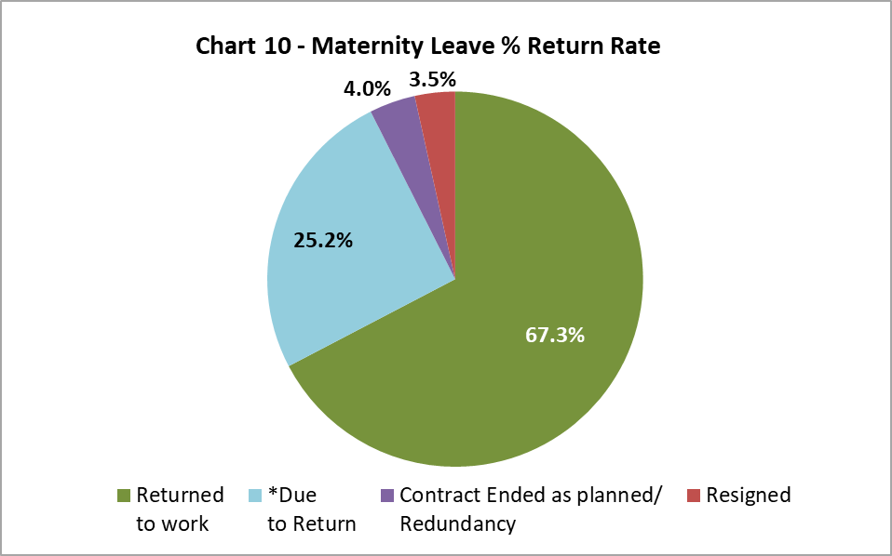

There has been a 1.2% decrease in resignations post maternity leave from 2020-21, when there was an unexpected increase. There has also been a 2.5% reduction in colleagues’ contracts ending whilst they are on Maternity Leave.

Gender Reassignment

30 colleagues responded negatively to the HESA recommended question relating to gender identity: ‘Does your gender identity match your sex as registered at birth?’. This represents a 30% increase from 2019-20.

Profile by Age

By College

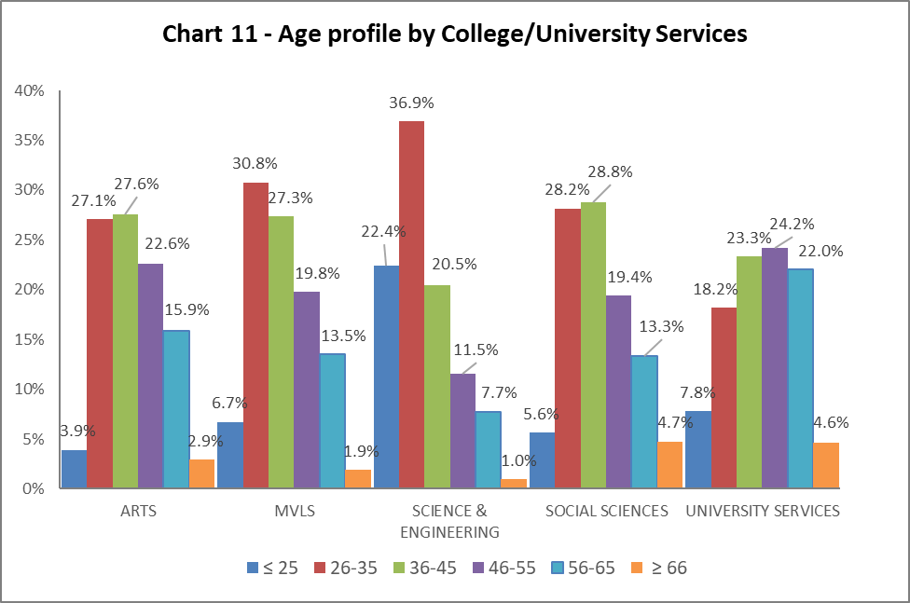

Table 7 | ARTS | MVLS | SCIENCE & ENGINEERING | SOCIAL SCIENCES | UNIVERSITY SERVICES
Age Range | % | % | % | % | %
≤ 25 | 3.9 | 6.7 | 22.4 | 5.6 | 7.8
26-35 | 27.1 | 30.8 | 36.9 | 28.2 | 18.2
36-45 | 27.6 | 27.3 | 20.5 | 28.8 | 23.3
46-55 | 22.6 | 19.8 | 11.5 | 19.4 | 24.2
56-65 | 15.9 | 13.5 | 7.7 | 13.3 | 22.0
≥ 66 | 2.9 | 1.9 | 1.0 | 4.7 | 4.6

Chart 11 above is visualisation of the distribution of ages in each College/US which can be compared with the Whole University distribution in Chart 1. Table 7 above gives the relevant percentages. It is generally a stable picture across the University. Arts has seen a 1.5% decrease within the 46-55 age range; MVLS has an increase by 2.6% in the 36-45 age range, along with a converse decrease of 2.5% in the 56-65 age range. Science and Engineering has seen a reduction in the 46-55 and 56-65 age groups by 2.7% and 1.3% respectively. Social Sciences has a static picture, while University Services has grown the percentage of 26-35 and 36-45 age range by 1.4% and 1.6% respectively, but their largest cohort of colleagues are aged 56 and over.

By Grade 10 staff
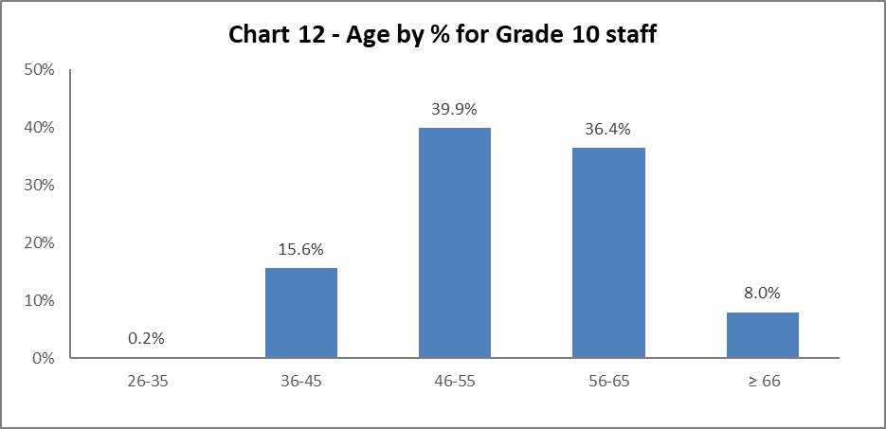

Chart 12 above shows most Grade 10 colleagues are aged 46 or over. There has been an increase in colleagues in Grade 10 in the 26-45 age range by 2.3% since 2020-21.

By Job Family Profile

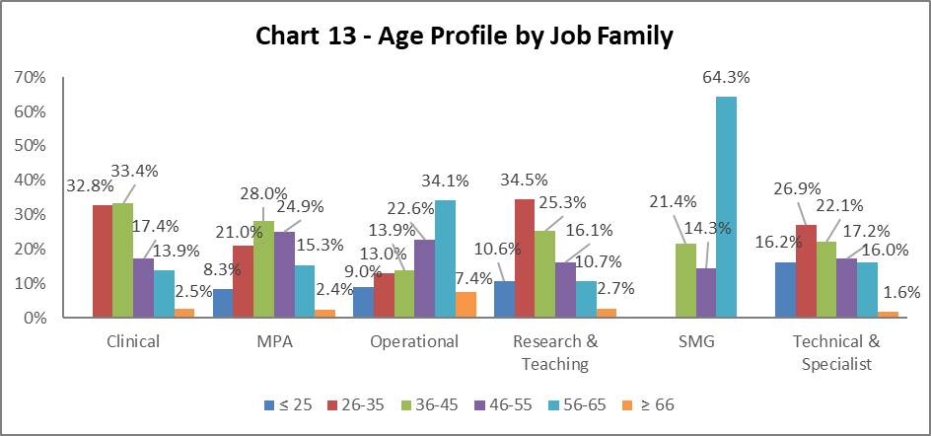

Table 8 | Clinical | MPA | Operational | Research & Teaching | SMG | Technical & Related
Age Range | % | % | % | % | % | %
Age ≤25 | 0.0 | 8.3 | 9.0 | 10.6 | 0.0 | 16.2
Age 26-35 | 32.8 | 21.0 | 13.0 | 34.5 | 0.0 | 26.9
Age 36-45 | 33.4 | 28.0 | 13.9 | 25.3 | 21.4 | 22.1
Age 46-55 | 17.4 | 24.9 | 22.6 | 16.1 | 14.3 | 17.2
Age 56-65 | 13.9 | 15.3 | 34.1 | 10.7 | 64.3 | 16.0
Age ≥66 | 2.5 | 2.4 | 7.4 | 2.7 | 0.0 | 1.6
Chart 13 above outlines the age distribution by job family. The majority of job families are similar to the previous year, the exception being Technical and Specialist job family which saw a marked reduction in the <25 age range by 13.9%. There has been a reduction in the 56-66 age range in the Operational job family by 3.7%, this is moving the job family toward a more natural bell curve.

By Grade

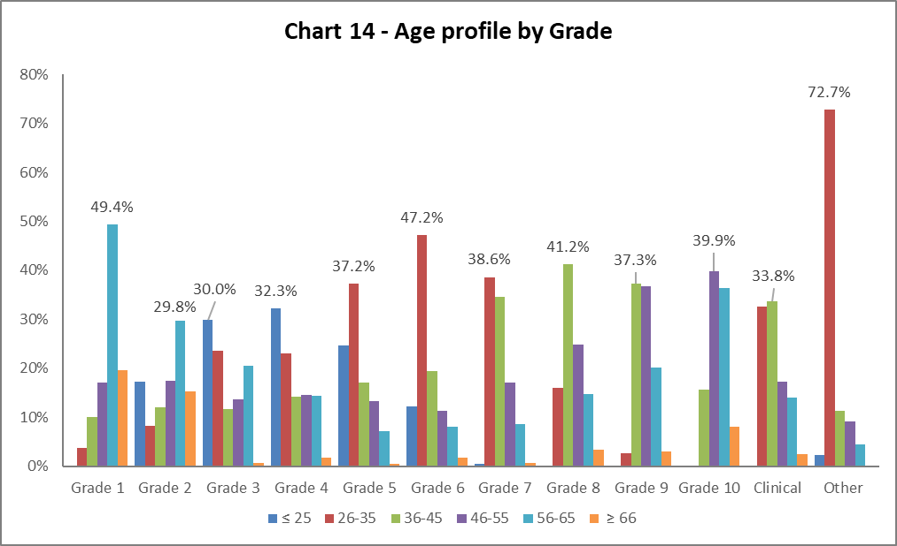

Table 9 | Grade 1 | Grade 2 | Grade 3 | Grade 4 | Grade 5 | Grade 6 | Grade 7 | Grade 8 | Grade 9 | Grade 10 | Clinical | Other
Age Range | % | % | % | % | % | % | % | % | % | % | % | %
Age ≤ 25 | 0.0 | 17.2 | 30.0 | 32.3 | 24.7 | 12.3 | 0.5 | 0.1 | 0.0 | 0.0 | 0.0 | 2.3
Age 26-35 | 3.8 | 8.2 | 23.5 | 22.9 | 37.2 | 47.2 | 38.6 | 15.9 | 2.7 | 0.2 | 32.5 | 72.7
Age 36-45 | 10.1 | 12.0 | 11.6 | 14.2 | 17.1 | 19.4 | 34.6 | 41.2 | 37.3 | 15.6 | 33.8 | 11.4
Age 46-55 | 17.1 | 17.5 | 13.6 | 14.6 | 13.2 | 11.3 | 17.1 | 24.8 | 36.8 | 39.9 | 17.2 | 9.1
Age 56-65 | 49.4 | 29.8 | 20.5 | 14.4 | 7.2 | 8.1 | 8.7 | 14.7 | 20.1 | 36.4 | 14.1 | 4.5
Age ≥ 66 | 19.6 | 15.3 | 0.7 | 1.7 | 0.6 | 1.7 | 0.6 | 3.3 | 3.1 | 8.0 | 2.5 | 0.0

Chart 14 and Table 9 show the grade profile for age range. The notable changes from 2020-21 are an increase of 14.8% in Grade 4 in the <25 age range, who make up the largest cohort in this grade, and a reduction of this age range in Grade 3 by 5.6%. All other Grades have similar age range patterns to those seen in previous years.

By Full/Part Time

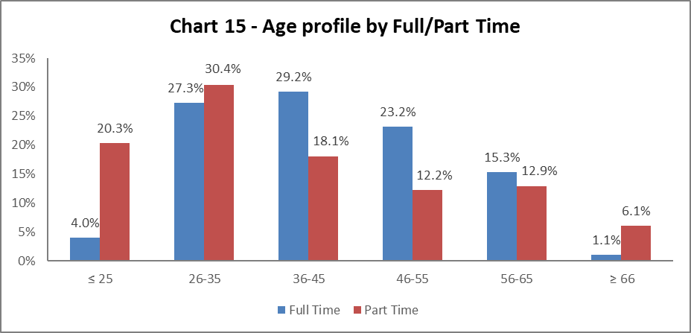

Chart 15 shows the age profile of both full time and part time colleagues. There has been a switch in the percentage of staff in the 56-65 age range and their work mode, with an increase in those working full time by 1% and a decrease of 3.1% for those working part time.

By Contract Type

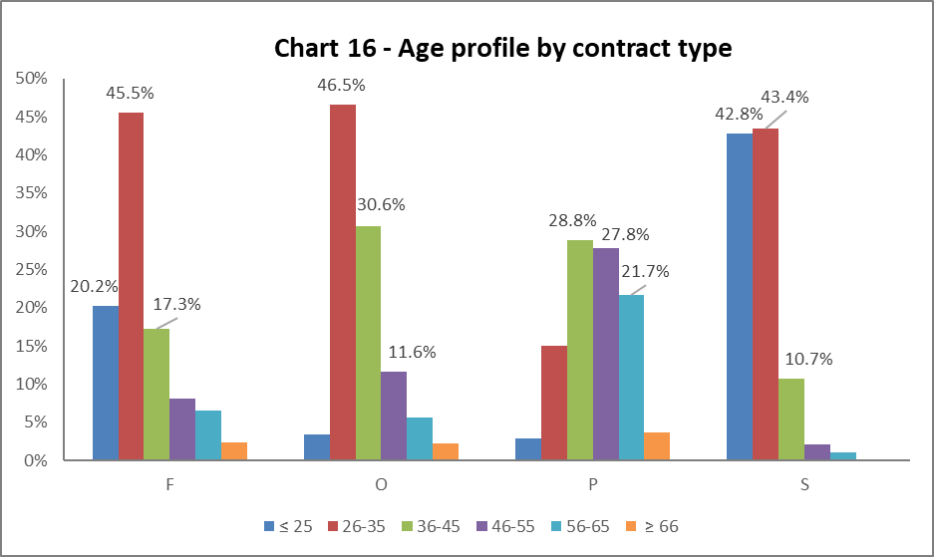

Key
F = Fixed term as per FT & OE Contract policy
O = Open ended with funding end date
P = Open ended (‘Permanent’) + Perm in Temp Fixed Term Appointment (HoC/Principal/VP role)
S = Fixed term - SOSR e.g. Maternity leave cover

Table 10 | F | O | P | S
Age Range | % | % | % | %
Age ≤25 | 20.2 | 3.4 | 2.9 | 42.8
Age 26-35 | 45.5 | 46.5 | 15.1 | 43.4
Age 36-45 | 17.2 | 30.6 | 28.8 | 10.7
Age 46-55 | 8.2 | 11.6 | 27.8 | 2.1
Age 56-65 | 6.6 | 5.6 | 21.7 | 1.1
Age ≥66 | 2.4 | 2.2 | 3.7 | 0.0

Chart 16 above shows that Open ended with Funding End Date (code O) and both types of Fixed Term (F & S) workers are generally younger (under 35), this reflects 2020-21 data. However there has been 39.9% increase in colleagues who are aged <25 on contract type S; this reflects the move to put more colleagues on this type of contract.

By Nationality

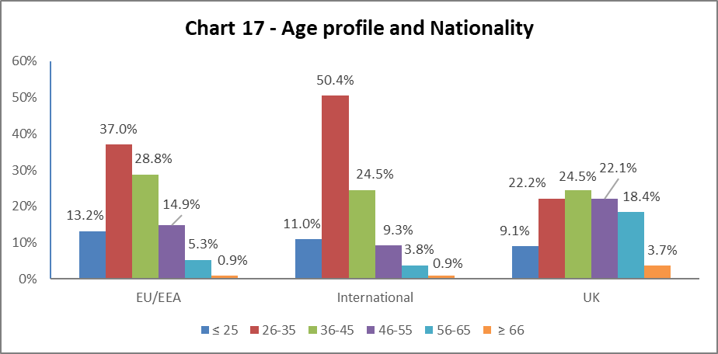

Table 11 | EU/EEA | International | UK
Age Range | % | % | %
Age ≤25 | 13.2 | 11.0 | 9.1
Age 26-35 | 37.0 | 50.4 | 22.2
Age 36-45 | 28.8 | 24.5 | 24.5
Age 46-55 | 14.9 | 9.3 | 22.1
Age 56-65 | 5.3 | 3.8 | 18.4
Age ≥66 | 0.9 | 0.9 | 3.7
Chart 17 and Table 11 shows the age range of staff and their nationality. As with previous years, a higher percentage of our EU/EEA and International staff are younger than our UK staff.

Recruitment – by Applications and Successful Applicants
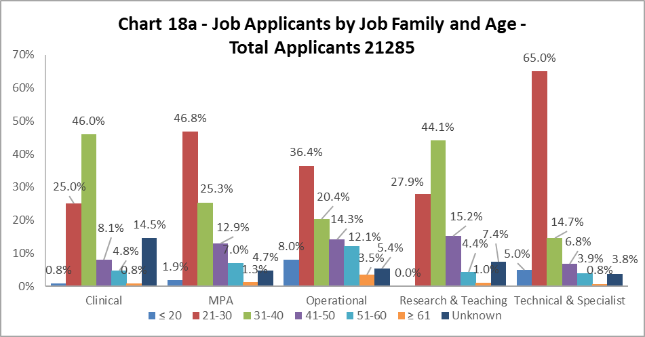
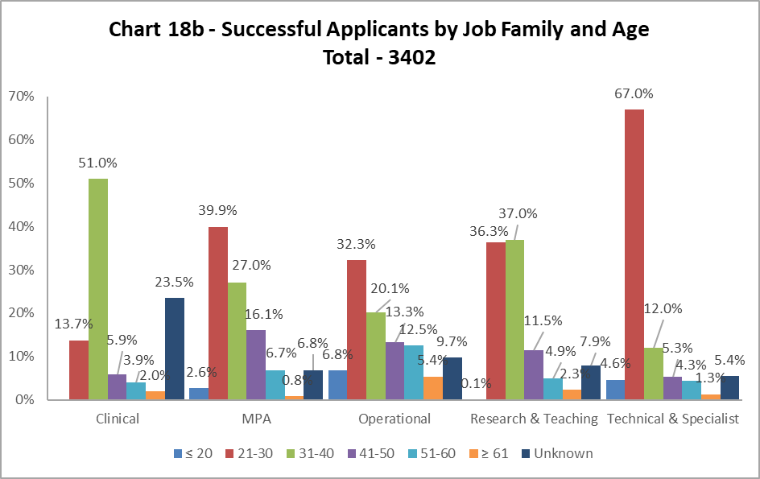

Charts 18a and 18b show the age of applicants and those who were successful. The biggest disparities are seen in the Research and Teaching job family, where applicants aged 21-30 are more likely to be successful, by 8.4%, and those aged 31-40 are 7.1% less successful. There continues to be high proportion of ‘Unknown’ in the data set.

Profile by Disability

By College

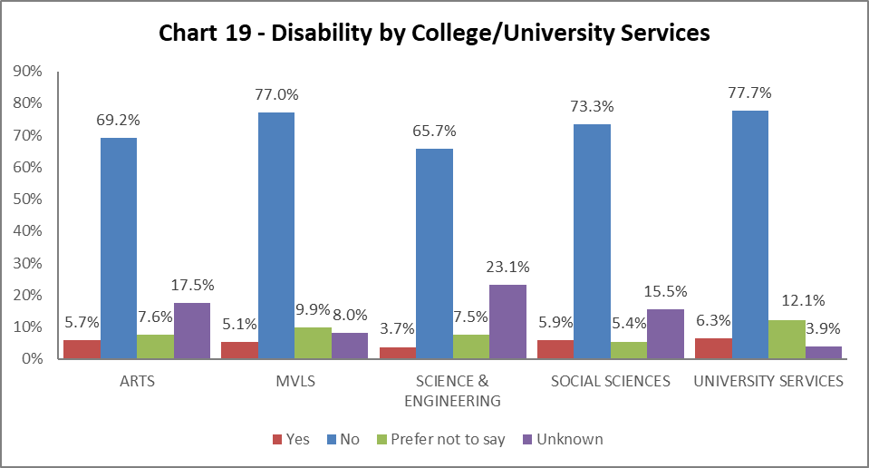

Chart 19 shows the percentage of declared disabled colleagues within College/University Services (US). All Colleges have seen an increase in declaration rates. The largest is Arts, with an increase of 1%, and the smallest is Social Sciences with 0.2%. US declared Disability rate is static from 2020-21. There have been varying rates of ‘Unknown’ and ‘Prefer not to say’ across the Colleges/US with Arts and Science and Engineering saw increases in their ‘Unknown’ by 2.2% and 2.3% respectively, and MVLS and US saw decreases in their ‘Prefer not to say’ rate by 3% and 2.1% respectively.

By Grade 10 staff

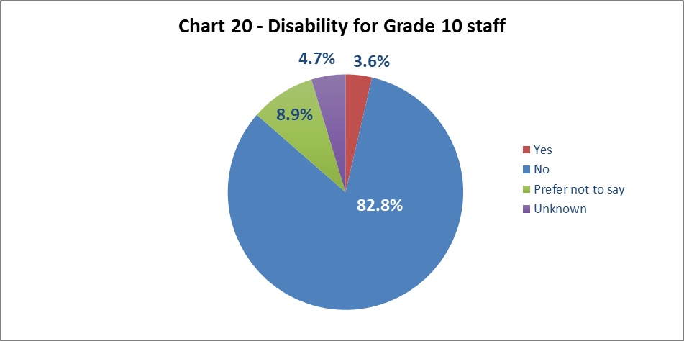

Chart 20 shows 3.6% of senior staff have declared a disability. While this is a 0.3% increase from 2020-21 it remains 1.7% lower than the University wide figure (5.3%).

By Job Family Profile

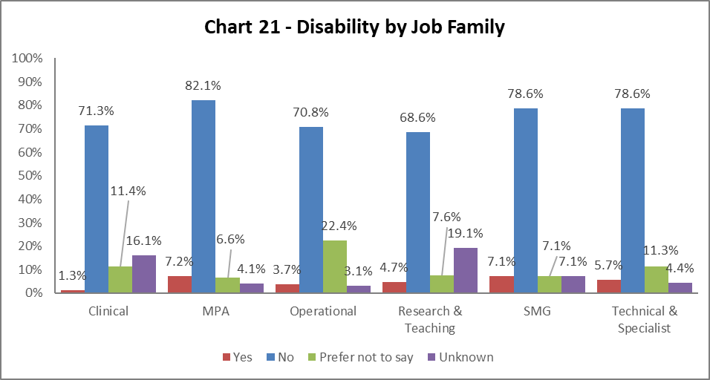

Chart 21 shows most job families have seen increased disability declaration rates from 2020-21, except for Clinical. The highest percentage is in MPA colleagues at 7.2%, however the biggest increases are in Operational and Technical and Specialist; both have risen by 0.6% from 2020-21. Across all job families there has been a drop in the respondents stating ‘Prefer not to say’.

By Grade

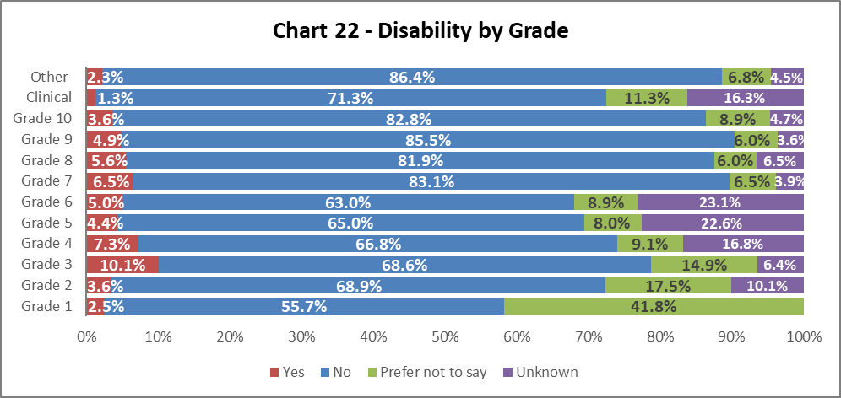

Chart 22 shows disability declaration rates by Grade. Declaration rates have increased since 2020-21 across the majority of grades, most notably in Grade 3 (by 3.1%), Grade 7 (by 0.8%) and Grade 9 (by 0.7%). In the same time period, the most notable decrease is in Grade 2 which has fallen by 1.4%. There continues to be high percentages of colleagues stating ‘Prefer not to say’ at lower grades.

By Full/Part Time

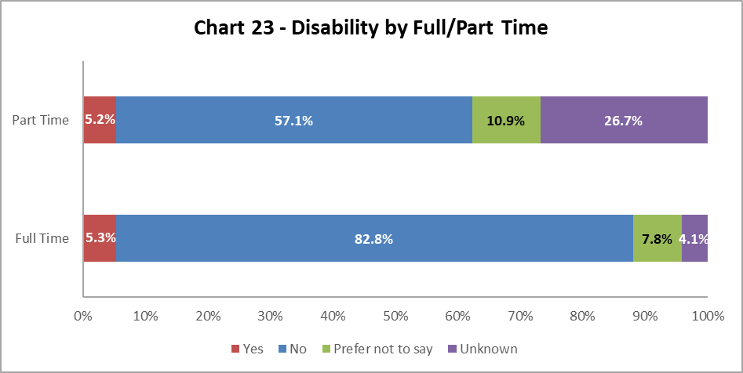

Chart 23 shows colleagues with a disability are equally as likely to work on a full time or part time basis. These declared disability percentages have increase since 2020-21 by 0.3% and 0.4% and now mirror the University wide figure (5.3%).

By Contract Type

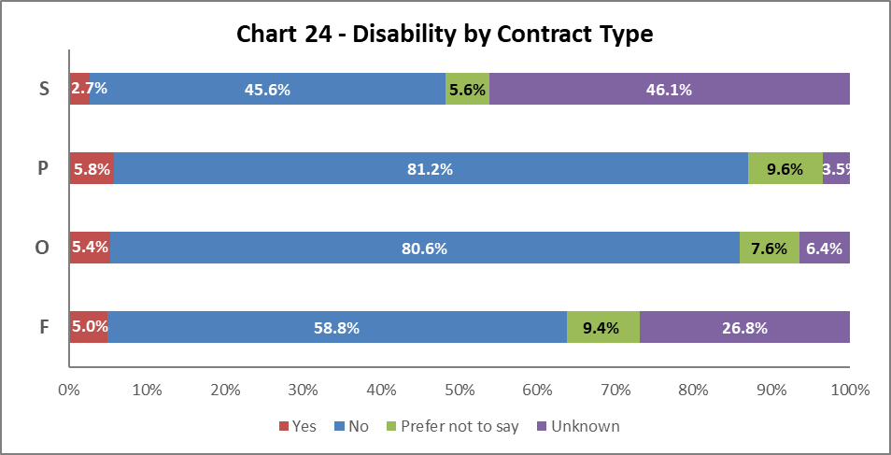

Chart 24 above shows disabled colleagues are most likely to have a Permanent contract (Code P), an increase 0.4% from 2020-21. There has been an increase in Disabled colleagues on Fixed term contracts (Code F) from 3.7% to 5% from 2020-21. There has been a reduction in Disabled staff on all other contract types. There has been a significant increase in ‘Unknown’ category on Fixed term - SOSR (Code S) contracts since 2020-21, by 35.3%.

By Nationality

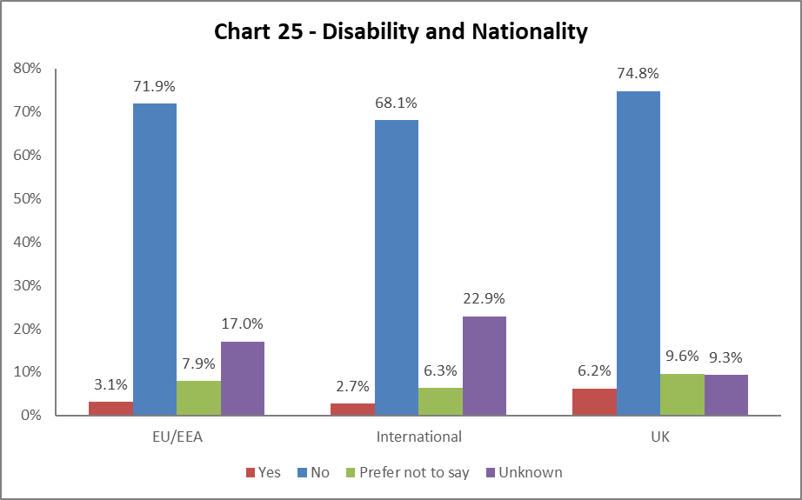
Chart 25 shows a higher proportion of colleagues from the UK (6.2%) have declared a disability compared to International and EU/EEA staff. However, the largest increased in declaration rates has been seen in colleagues from the EU/EEA, up by 0.9% since 2020-21.

BSL Users

As part of the University’s British Sign Language (BSL) Action Plan we have reviewed the number of staff who declared a level of proficiency in the use of BSL. 17 staff have declared a level of proficiency, the majority at beginners level.

Recruitment – by Applications and Successful Applicants
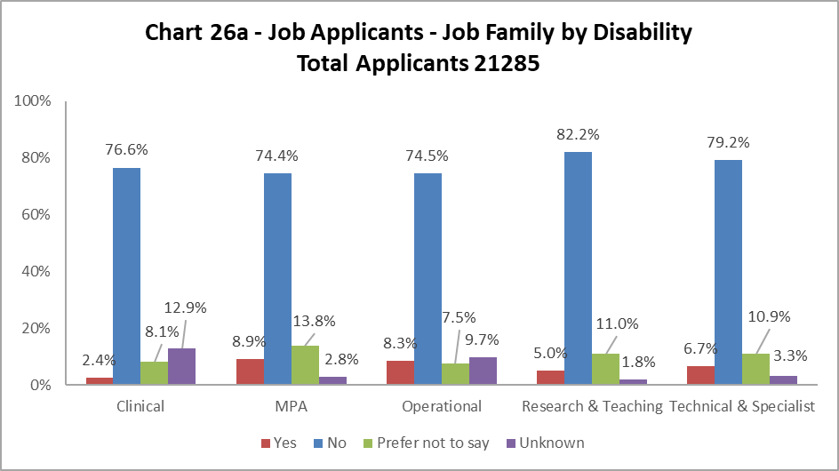

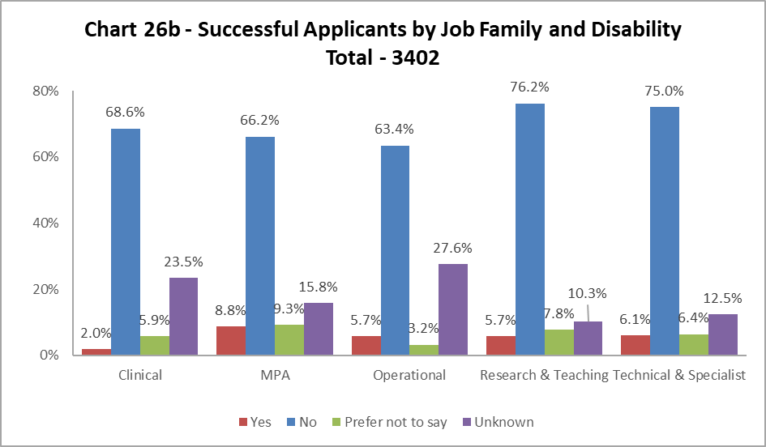

Charts 26a and 26b shows most job families had slightly more disabled applicants than were successfully appointed. Most differences were relatively small, however in the Operational job family the difference was 2.6%. The exception was in Research and Teaching where 5.0% of applicants were disabled which increased to 5.7% of the successful applicants. The percentages of ‘Unknown’ is large across the data set and increased in the successful applicant pool. This is particularly marked in the Operational staff, where the disability status of over a quarter of successful applicants was ‘Unknown’.

Profile by Ethnicity

By College

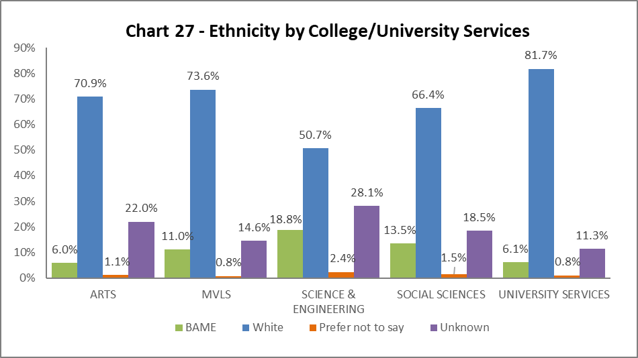

Chart 27 shows the breakdown by ethnicity of colleagues in College/US. The percentage of ethnic minority colleagues increased across all Colleges/US – most notably with a rise of 3.5% in Science and Engineering, with Social Sciences rising by 1.9%, MVLS rising by 1.4%, US rising by 1% and Arts up by 0.5%. The percentages of colleagues with ‘Unknown’ ethnicity continues to be high, however, there have been reductions in MVLS.

By Grade 10 Staff

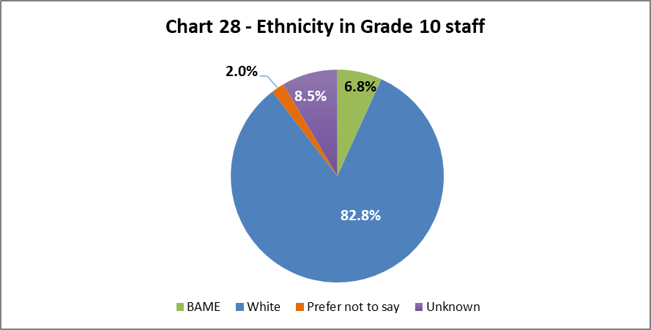

Chart 28 above show the ethnicity of staff at Grade 10. There has been an increase of 0.9% in BAME colleagues in senior roles since 2020-21.

By Job Family Profile
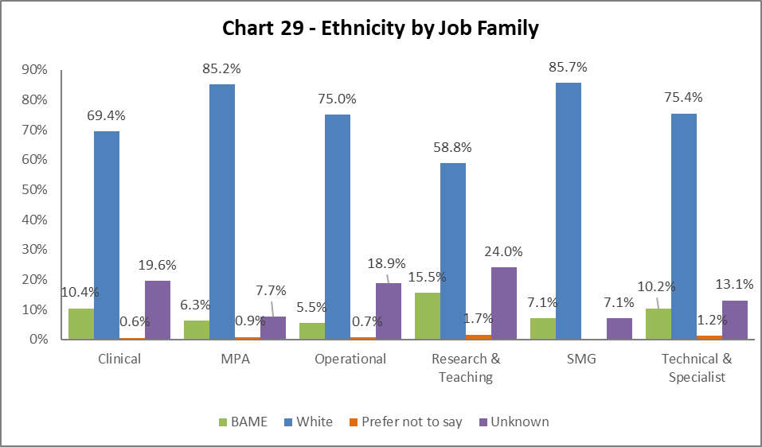

Chart 29 shows the ethnicity of colleagues by job family. There has been an increase in BAME colleagues across all job families since 2020-21, with the exception of Clinical which saw a minor fall. The biggest increase has been in Research and Teaching job family of 2.3%. All job families continue to have high percentages of ‘Unknown’, most notably in the Research and Teaching, Operational and Clinical job families.

By Grade

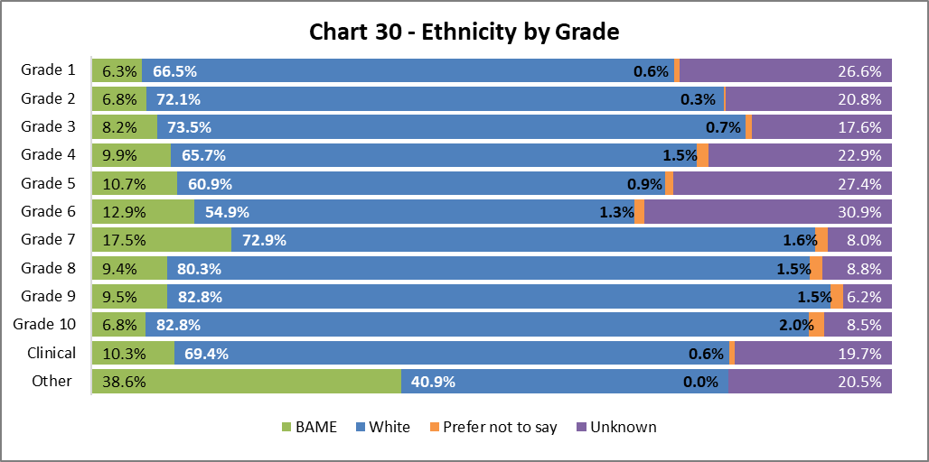

Chart 30 above shows the grade and ethnicity of colleagues. There has been an increase in BAME colleagues in most grades, the exceptions are Grade 1 and Clinical. The largest increases are in Grades 5 and 6, increasing by 3.2% and 2.4% respectively since 2020-21. The largest cohort of BAME colleagues are in the Other category, though this is a very small cohort of the Univesity population (0.5%, see table 5).

By Full/Part Time

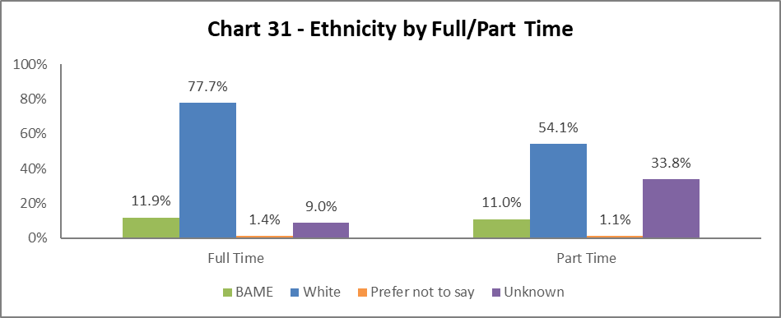

Chart 31 shows the ethnicity of colleagues working full time and part time. Both cohorts have seen increased rates of BAME colleagues since 2020-21. The part time cohort has increased by 3.6%.

By Contract Type

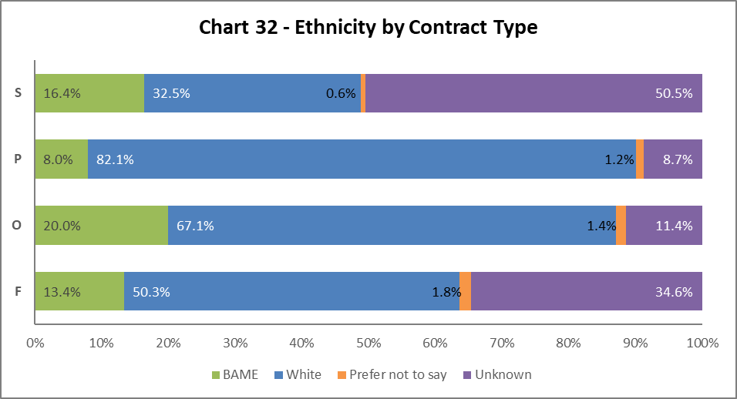

Chart 32 shows the percentage of BAME colleagues has increased since 2020-21 across all contract types. This is highest in Open Ended with Funding End Date (type O), which is 20%. The largest growth has been in BAME colleagues on SOSR contracts (type S) which has increased by 7.6%. Both SOSR (type S) and Fixed Term (type F) have high ‘Unknown’ categories.

By Nationality

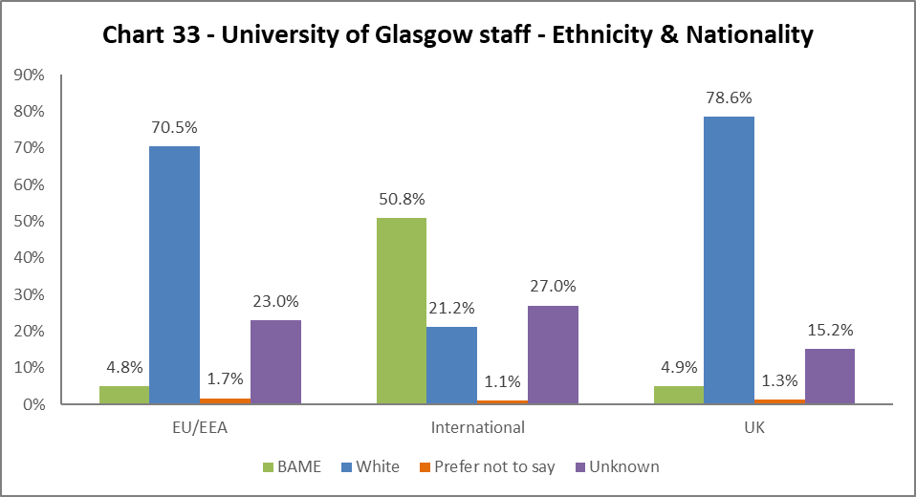

Chart 33 outlines the nationality and ethnicity of our staff. 50.8% of our International colleagues are from BAME backgrounds, an increase of 5.3% from 2020-21. Of our UK staff, only 4.9% are from BAME backgrounds – however this is an increase of 0.8% from 2019-20.

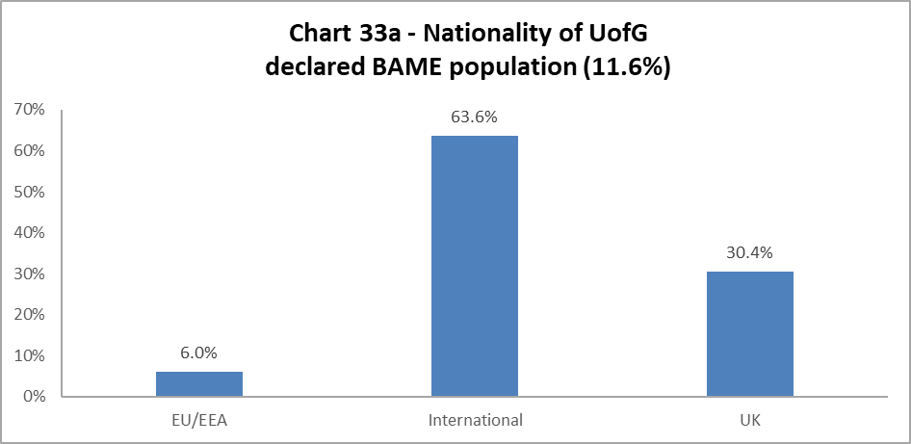
Chart 33a outlines the nationality of our whole BAME staff population (11.6% of total – see Chart 6a). Almost two-thirds of BAME colleagues are from International backgrounds.

Recruitment – by Applications and Successful Applicants

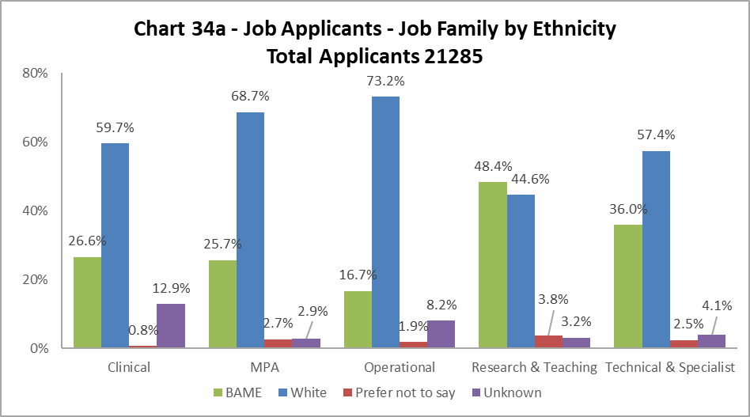

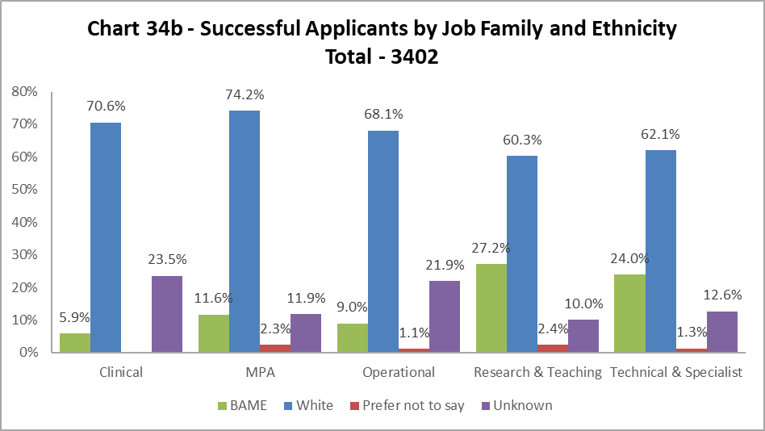

The data, as illustrated by Chart 34a and 34b, shows BAME applicants are proportionally less likely to be successful in all job family profiles. The greatest differences are seen in the Research & Teaching and Clinical job families, mirroring 2020-21, with the drops of over 20%. It should be noted there are relatively low number of jobs advertised in the Clinical job family. The drop in BAME successful applicants, of over 10% in both MPA and Technical & Specialist job families, is also recognised as large.

Profile by Sex

By College

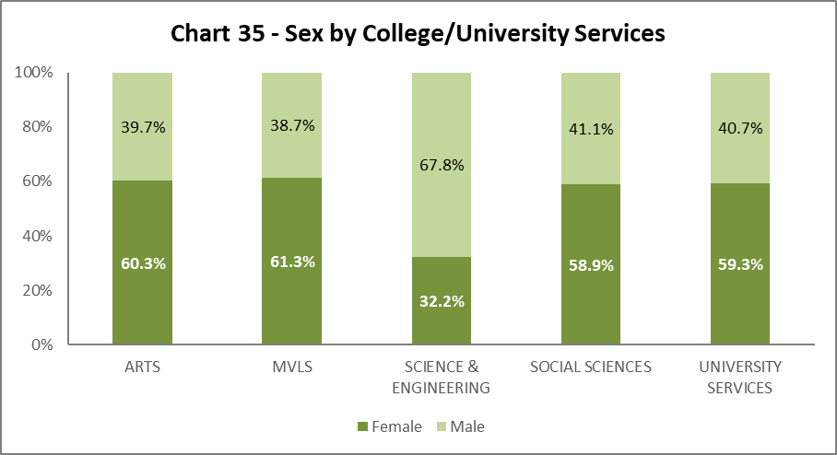

Chart 35 shows the split by Sex in College/US. Science and Engineering has seen a drop in females by 1.2% and MVLS have seen an increase in males by 2.3%. All other Colleges/US have only seen minor fluctuations.

By Grade 10 Staff

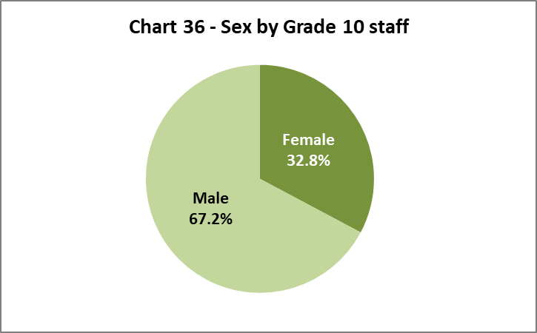

Chart 36 illustrates 32.8% of senior colleagues are Female, this is a small reduction from 2020-21 by 0.4%.

By Job Family Profile

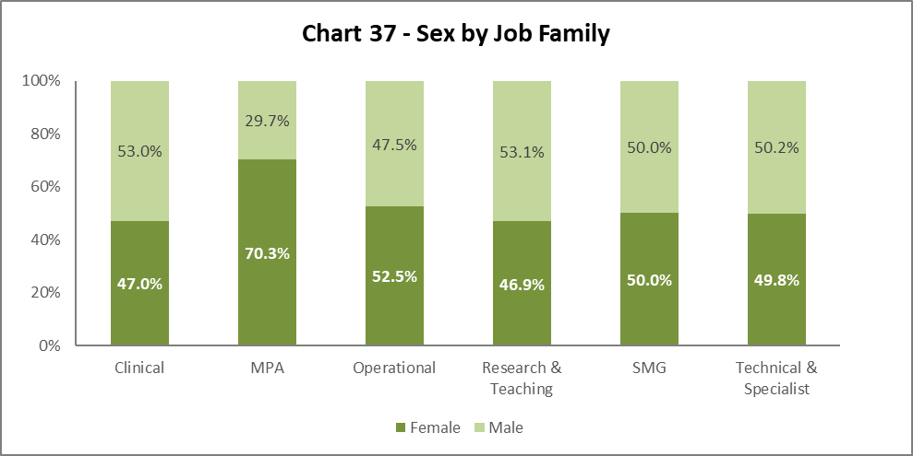

Chart 37 shows SMG is 50/50 Female to Male. There are other minor fluctuations across the job families – a decrease in females in Clinical (by 2.9%) and an increase in Operational job family by 1.4%.

By Grade

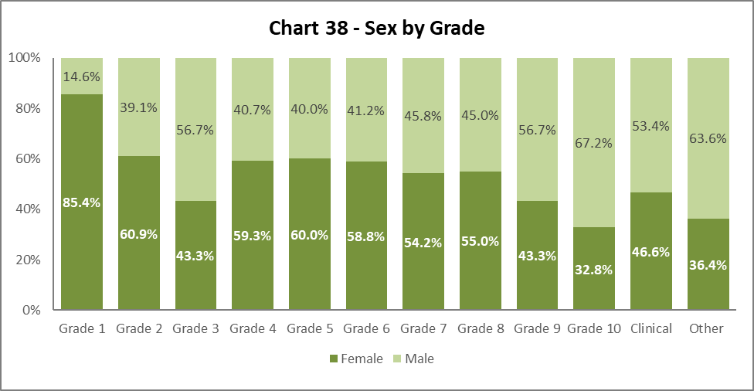

Chart 38 shows similar proportions of females and males in each grade when compared to last year. There is a notable increase in females in Grade 2 (by 9%) and Grade 8 (by 1.1%) and increase in males in Grade 4 (by 6.8%). In general, the chart shows the usual curve, with increasing percentages of females from Grade 4 to 8 and increasing males in Grade 9 and 10.

By Full/Part Time

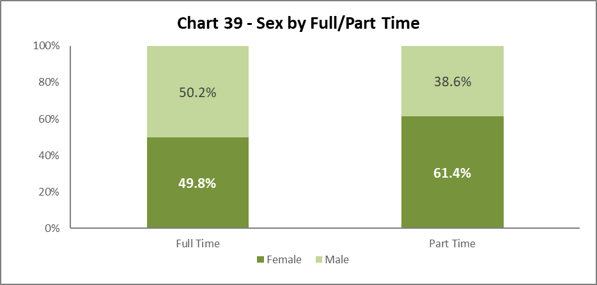

Chart 39 illustrates the breakdown by Sex of Full and Part Time staff. There has been a minor increase in the percentage of females working full time by 0.9% and a reduction in the percentage of females working part time by 2.8% since 2020-21.

By Contract Type

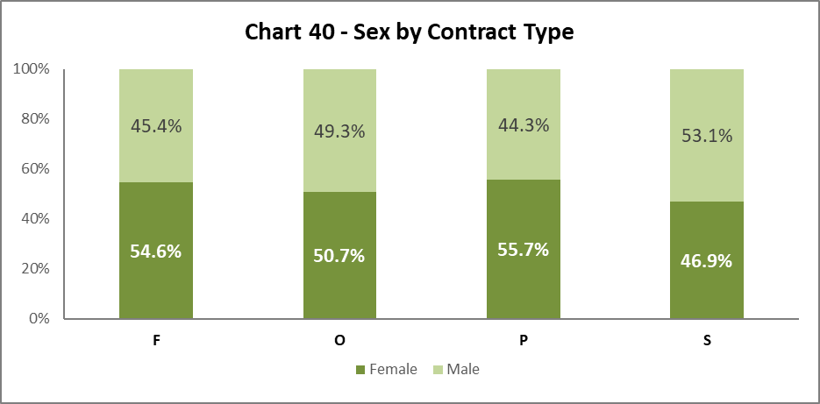

Chart 40 shows Sex by contract type. There has been little change from 2020-21 in contract types F, O & P. Contract type S has seen a 13.9% decrease in the percentage of females since 2020-21.

By Nationality

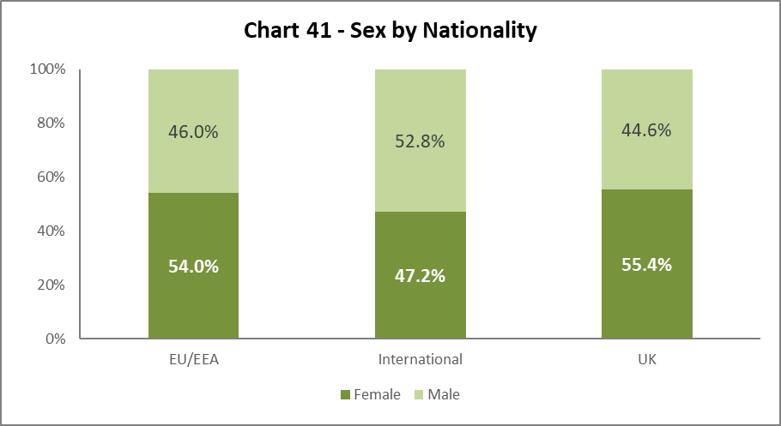
Chart 41 shows a similar picture to 2020-21 and 2019-20; Females and Males are almost equally represented from UK and EU/EEA. We have a higher proportion of Male International colleagues, although the Female representation has increased by 1.7% since 2019-20.

Recruitment – by Applications and Successful Applicants

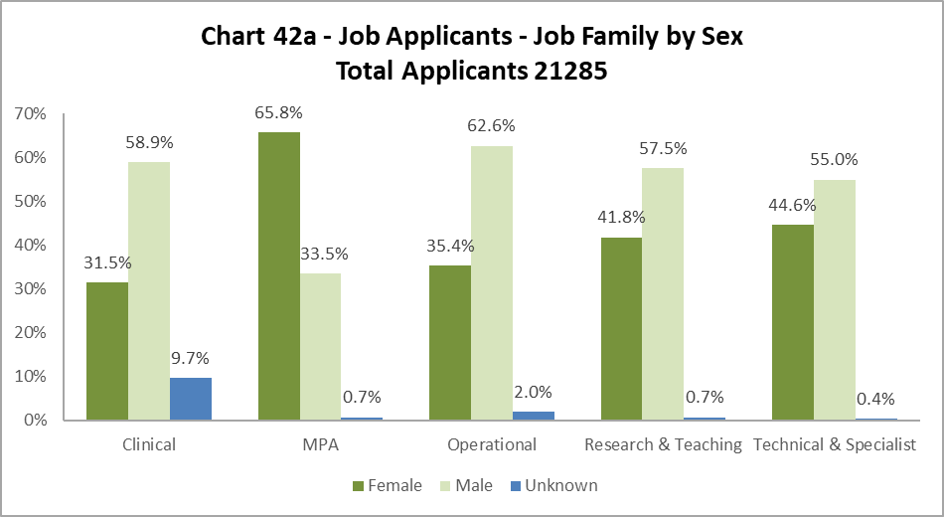

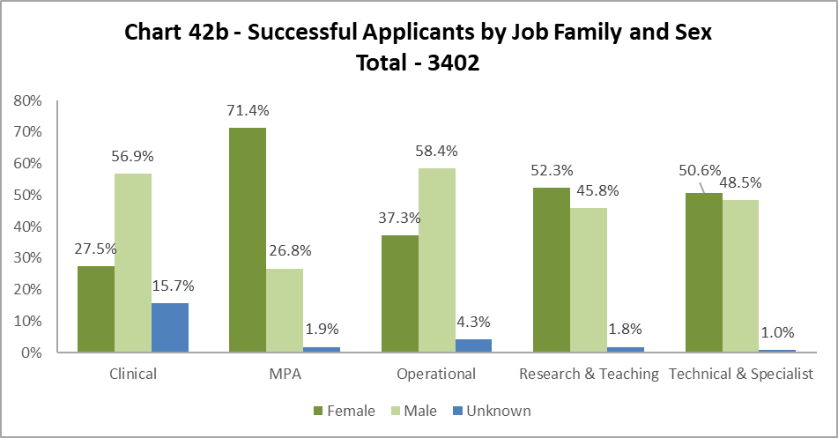

Charts 42a and 42b indicate Females are usually more successful than Males. This is noticeable in the Research & Teaching and Technical & Specialist job families, where the percentage of male applicants is higher than those from females.

Profile by Sexual Orientation

31.3% of all staff have not answered the question on Sexual Orientation. As such ‘Unknown’ figures have been excluded from these graphics but have been included in the statistics which are used to create them.

By College

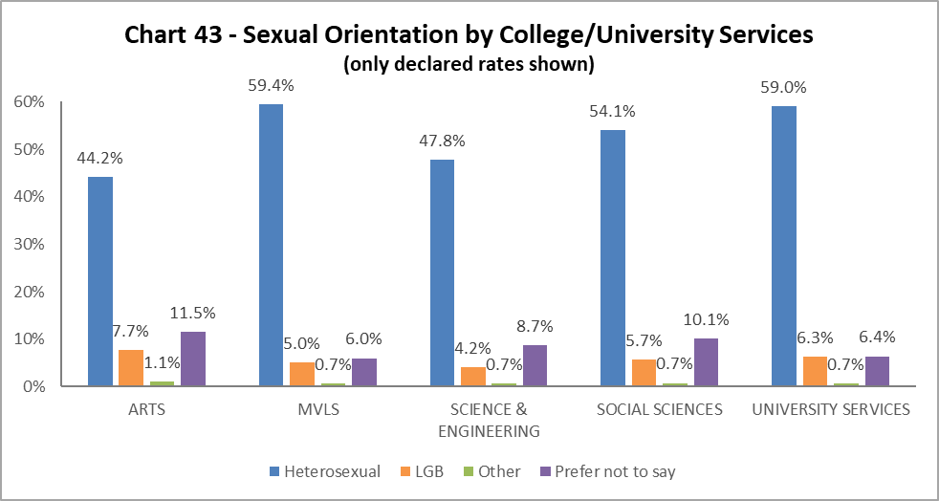

Chart 43 outlines the percentage of colleagues who have declared their LGB status. All Colleges/US, have seen increases since 2020-21, most notably in Science and Engineering who had a rise of 1.5%, though it remains the area with lowest declared LGB rate. The highest percentage of LGB colleagues are in Arts, then US and Social Sciences.

By Grade 10 Staff

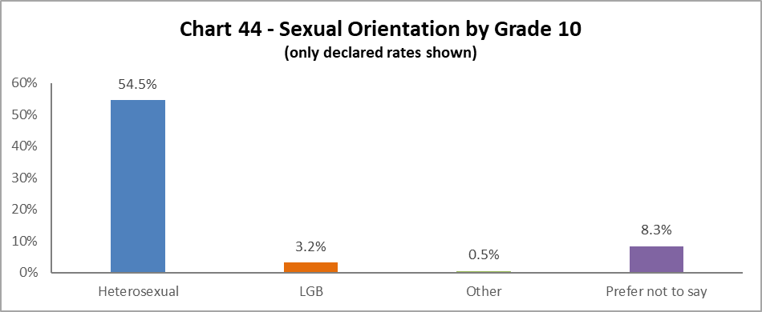

3.2% of Grade 10 colleagues identify as LGB, this is a minor drop of 0.1% since 2020-21.

By Job Family

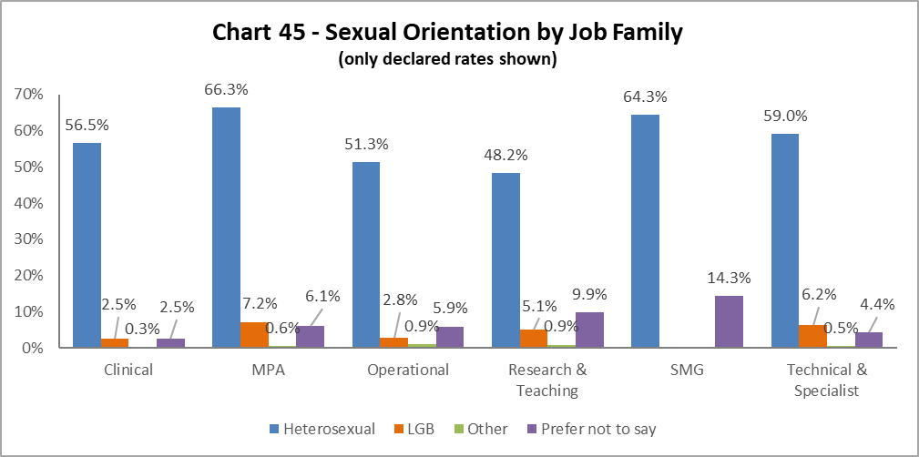

The highest proportion of LGB staff (7.2%) are in the MPA job family, which saw increase of 0.5% from 2020-21. There has also been a notable rise in the percentage of Research & Teaching colleagues by 1%, and Clinical colleagues by 0.9% since 2020-21.

By Grade

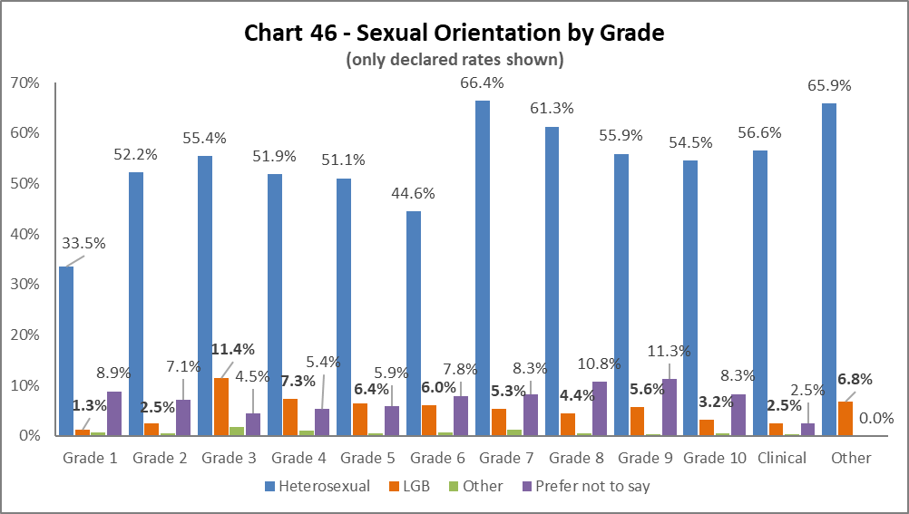
LGB declarations have increased across the majority of grades; the exception is Grade 1. In most grades the increase is between 0.5% to 1%. The highest proportion of LGB colleagues are in Grade 3 at 11.4%.

By Full/Part Time

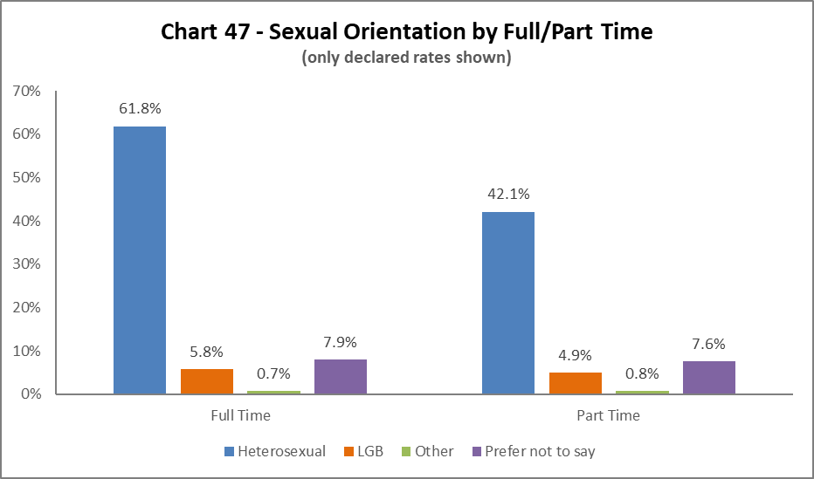
More LGB colleagues work Full Time, however we have seen an increase of 1.4% of LGB colleagues working part time since 20202-21.

By Contrast Type

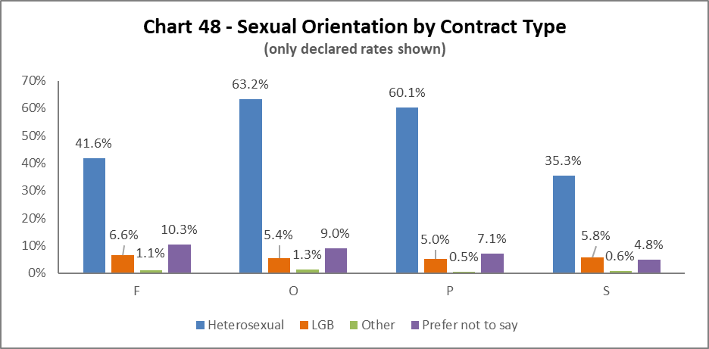
The highest proportion of LGB colleagues are on the Fixed term (code F) contracts, however this is a very small percentage of staff. The next highest are on SOSR contracts (type S), all contract types have seen an increase in LGB colleagues declaring since 2020-21.

By Nationality
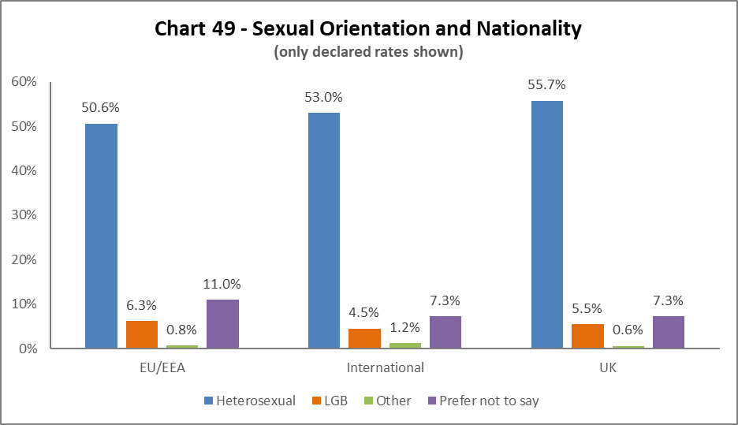
The highest proportion of LGB colleagues are from the EU/EEA, a 2.2% increase from 2019-20. There has been a 0.6% increase in UK and 0.7% increase in International LGB colleagues since 2020-21.

Recruitment – by Applications and Successful Applicants

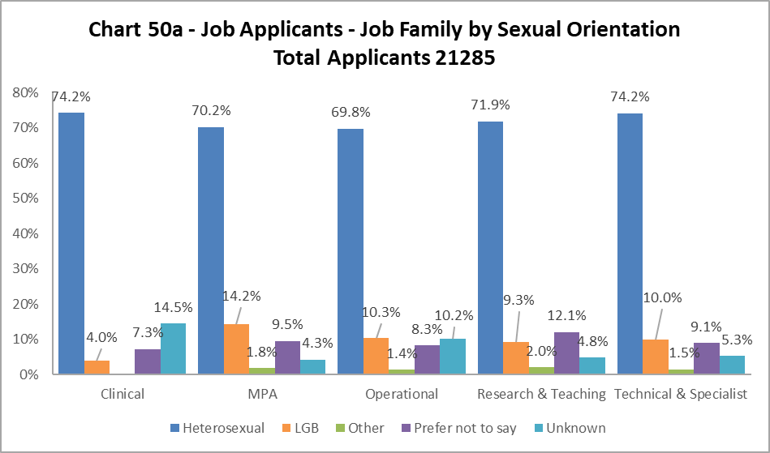

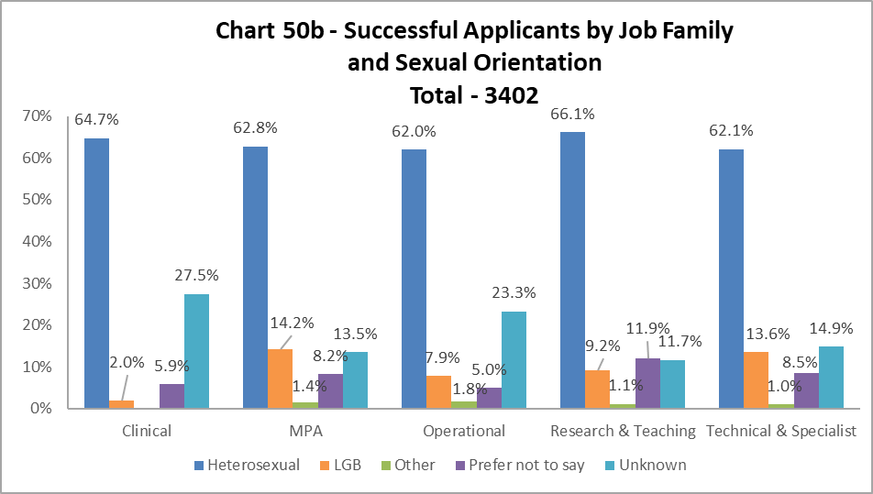

The proportion of successful LGB applicants closely matches that of the applicant pool across most job families, the exceptions being Clinical and Operational staff, where there are minor drops, and Technical & Specialist where LGB applicants are more likely to be successful.

Case Management – General

2021-22 saw a 16.5% decrease in the number of Managing Attendance (previously known as Capability), Discipline and Grievance cases – 86 in total, compared to 103 cases in 2020-21, however this level of case work is still higher than those seen in 2018-19 (61) and 2019-20 (33).

By Sex

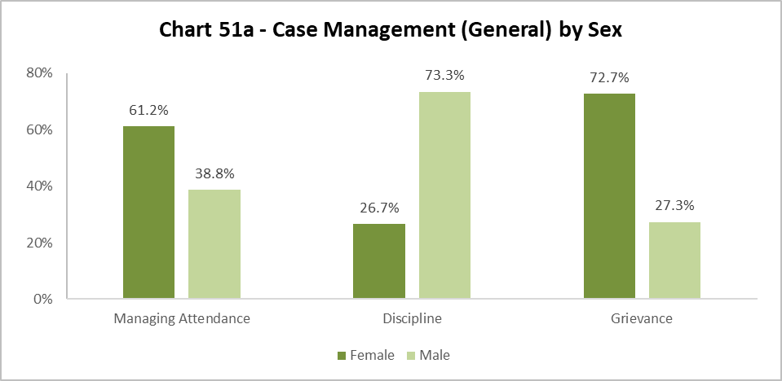

Chart 51a shows a higher percentage of those involved in Managing Attendance cases were Females, however the male/female split is similar to 2020-21. Males were significantly more likely to be taken through a Disciplinary process, although a slight drop from 2020-21 where 78.6% of cases were male. Females were more likely to take a Grievance, an increase of 24.9% from 2020-21, where this was more evenly split between the sexes.

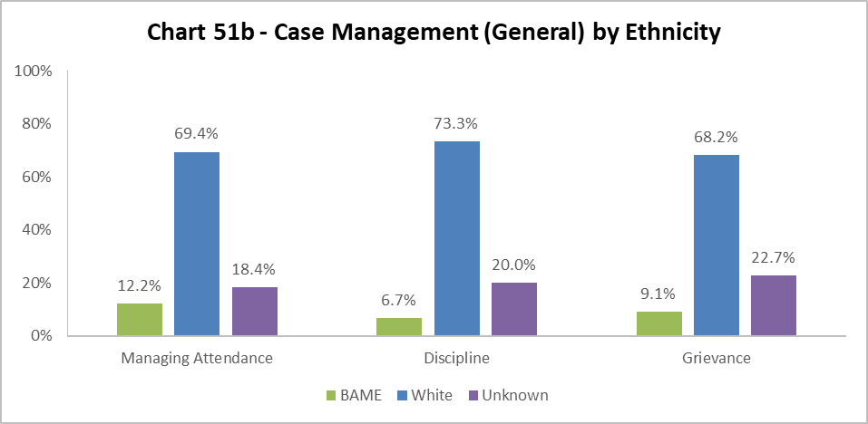
Chart 51b considers the ethnicity of colleagues involved in case management, and is included in this report for only the second time. The whole University BAME population is 11.6%. The percentage of BAME colleagues involved in Managing Attendance cases is slightly higher and double the 2020-21 percentage. The percentage of Grievances taken by BAME colleagues has also more than doubled, an increase of 4.8%. Discipline cases involving BAME colleagues saw a minor drop from 2020-21, by 0.4%.

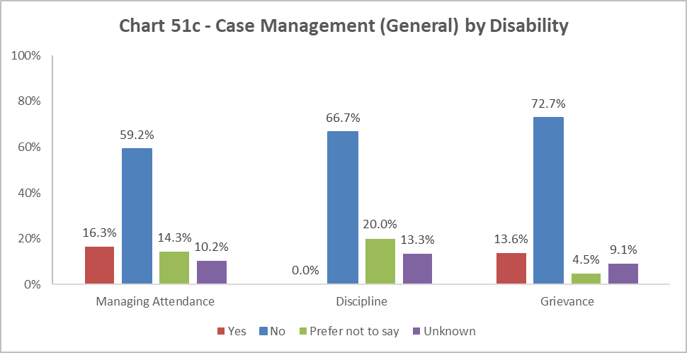

Chart 51c, considers the disability status of colleagues involved in case management cases, and is included for only the second time in this report.

As the University population of disabled colleagues is 5.3%, more than three times this percentage are involved in Managing Attendance processes, at 16.3%. This figure is also a 6.3% increase from 2020-21. There was a higher proportion of Disabled colleagues taking Grievances, more than double the University proportion of Disabled colleagues and up by 4.9% on 2020-21. There have been no Disabled colleagues involved in a Disciplinary process, this mirrors 2020-21.

As this is only the second year of considering Ethnicity and Disability Case Management data, we would still need to look at future years to establish any patterns.

Case Management – Sickness

The sickness figures relate to colleagues who have been absent for 20 or more continuous working days between 01 August 2021 – 31 July 2022. This involves 5% of those under report. This is an increase of 1.1% from 2020-21.

Age

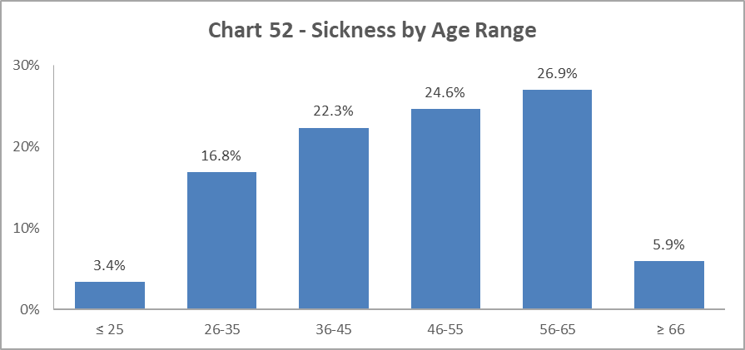

Chart 52 shows most colleagues who were off sick for 20 days or more, were in the 56-65 age group, this reflects 2020-21. However, the spread across the age ranges is more even, so although those aged 56-65 have the highest sickness absence rate, the percentage is 10% lower than in 2020-21.

Disability

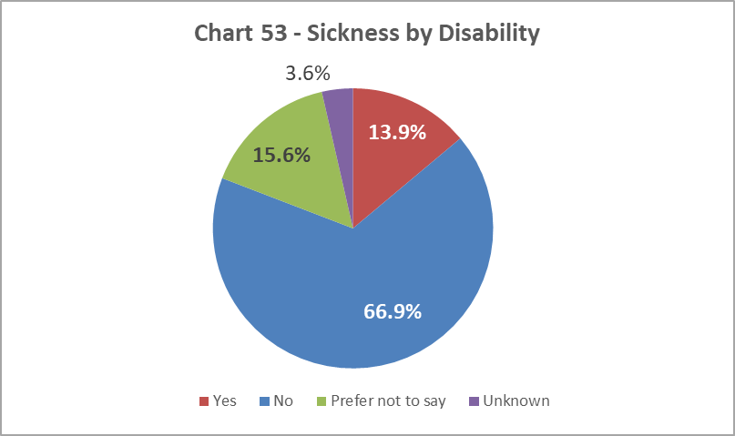

Chart 53 shows the proportion of disabled colleagues absent for 20 days or more was 13.9%, which represents an increase of 4.7% from 2019-20.

Ethnicity

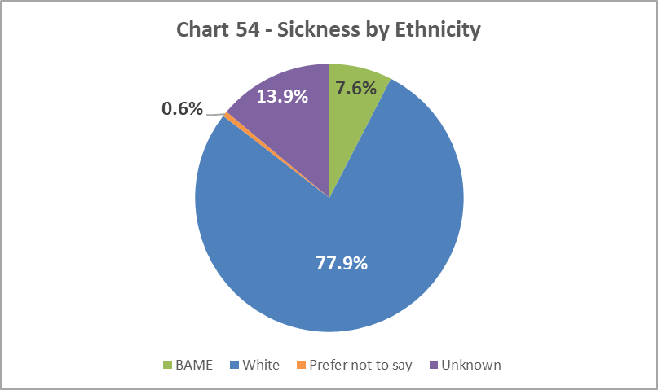

Chart 54 shows that, of colleagues who were off sick for more than 20 days, 7.6% are from a BAME background; this is a 2.7% increase since 2020-21.

Sex

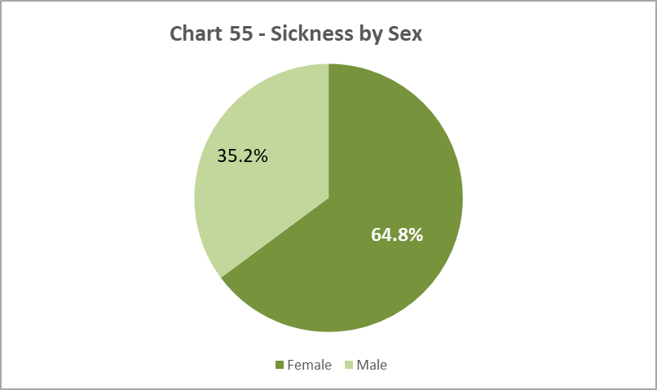

As in previous years, a higher proportion of Female colleagues have been off sick for 20 days or more than the overall University population (54%) as illustrated in Chart 8 and represents an increase of 1.8% from 2020-21.

Sexual Orientation

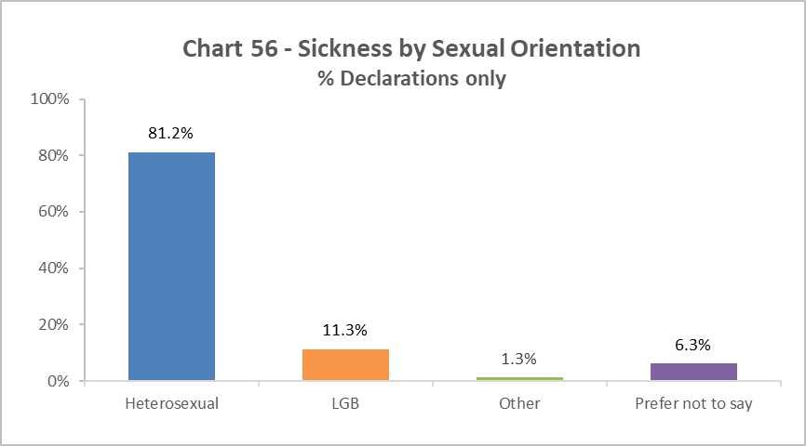

Chart 56 shows that of those who were off sick for more than 20 days, 11.3% declared as LGB, this is higher than the University wide LGB declaration rate. In addition, this is an increase of 3.7% on 2020-21 rates, and 6.9% from 2019-20.

Academic Promotions

Table 12 - Academic Promotions 2022 - R&T and Clinical Job Families Only
Grade Applied For |  | Success Rate  For Grade | Female | Male
GRADE 7 | Applicants |  | 44% | 56%
 | Successful |  | 48% | 53%
 | Promoted (%) | 80% | 86% | 75%
GRADE 8 | Applicants |  | 54% | 46%
 | Successful |  | 54% | 46%
 | Promoted (%) | 93% | 92% | 94%
GRADE 9 | Applicants |  | 50% | 50%
 | Successful* |  | 51% | 49%
 | Promoted (%) | 87% | 88% | 86%
READER | Applicants |  | 33% | 67%
 | Successful* |  | 33% | 67%
 | Promoted (%) | 57% | 57% | 57%
CLINICAL | Applicants |  | 50% | 50%
 | Successful |  | 43% | 57%
 | Promoted (%) | 100% | 100% | 100%
PROFESSOR | Applicants |  | 43% | 57%
 | Successful* |  | 39% | 61%
 | Promoted (%) | 89% | 81% | 95%
SUCCESS RATE FOR ALL APPLICANTS % |  | 86% | 86% | 85%

*Includes those who were unsuccessful in their application to this grade but were successful in gaining promotion to a Grade above their current Grade.

Table 12 provides breakdown by Sex of the Academic Promotions 2021-22 process. The overall success rate is higher for Females than Males, reflecting 2020-21. At each grade there are marginal difference between the success rates of each sex, however Females are more successful at Grade 7 with Males more successful when applying for Professor.

Regrading for Professional & Support Staff

Table 13 - Regrading 2021-22 - Professional and Support Staff by Grade
Grade Applied For |  | Success Rate | Female | Male
GRADE 1-5 | Applicants |  | 63% | 38%
 | Successful |  | 63% | 38%
 | Promoted (%) | 100% | 100% | 100%
GRADE 6-10 | Applicants | 25 | 66% | 34%
 | Successful | 23 | 62% | 38%
 | Promoted (%) | 92% | 92% | 92%
SUCCESS RATE FOR ALL APPLICANTS % |  | 94% | 94% | 95%

Table 14 - Regrading 2021-22 - Professional and Support Staff by Job Family
Job Family |  | Success Rate | Female | Male
MPA | Applicants |  | 77% | 23%
 | Successful |  | 75% | 25%
 | Promoted (%) | 93% | 91% | 100%
OPERATIONAL | Applicants |  | 0% | 100%
 | Successful |  | 0% | 100%
 | Promoted (%) | 100% | 0% | 100%
TECH & SPEC | Applicants |  | 57% | 43%
 | Successful |  | 60% | 40%
 | Promoted (%) | 95% | 100% | 89%
SUCCESS RATE FOR ALL APPLICANTS % |  | 94% | 94% | 95%

Table 13 above shows applications for regrading by Sex were equally successful in 2021-22.

Table 14 shows much higher percentages of Females applying for regarding in the MPA job family which roughly reflects the make-up of this Job Family (Chart 37). All Male MPA applicants were successful, whilst not all the Females were. Conversely, a higher percentage of Females in Technical & Specialists job family were successful than Males. Reflecting 2020-21, the Operational job family saw no applications from Females seeking regrading.

Equal Pay
The University has a duty to publish pay gap information by 30th April every two years under Regulation 7 of the Equality Act 2010 (Specific Duties) (Scotland) Regulations 2012. The most recent Equal Pay reports for Gender, Ethnicity and Disability was published in April 2021, the next report will be published by April 2023.

END.

As in previous years, MRC staff have been removed from this category and reallocated to the relevant grade based on salary scales.

