It is easier to user the auto setup tool at www.gla.ac.uk/eduroam

Open the Start Menu and search for Control Panel
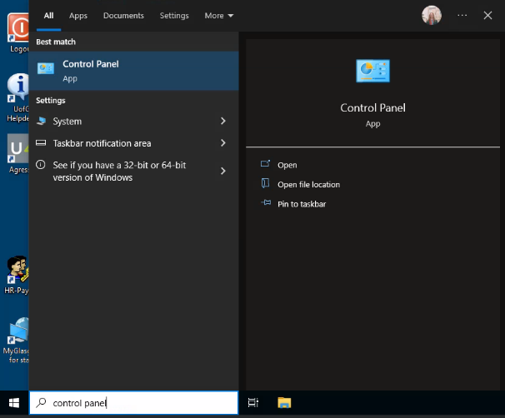
In the Control Panel, select Network and Sharing Centre. You may have to use the search in the top right to find it.
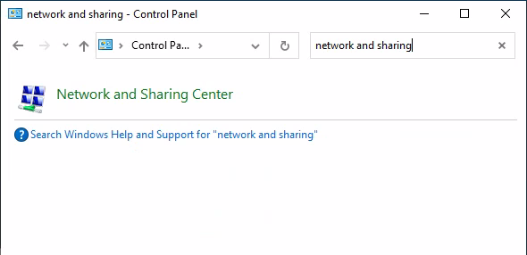
In the Network and Sharing centre, click Set up a new connection or network
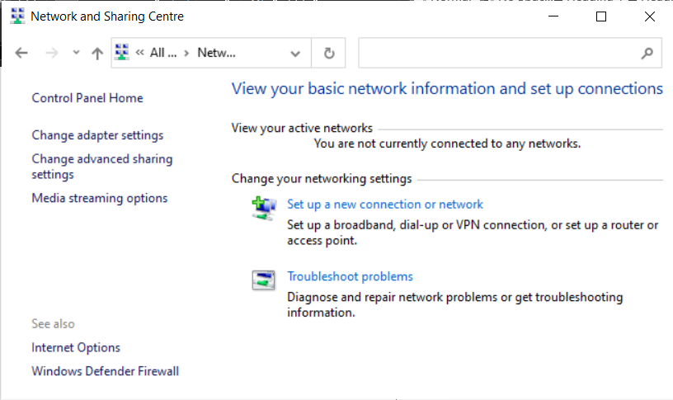

Select Manually connect to a wireless network
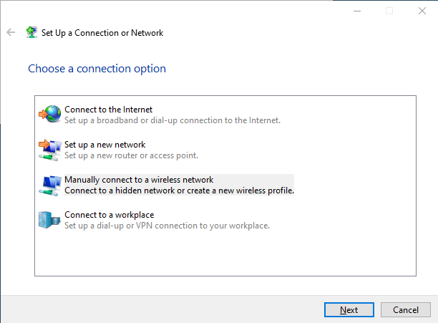
Enter the details as follows then click next
- Network name: eduroam
- Security type: WPA2-Enterprise
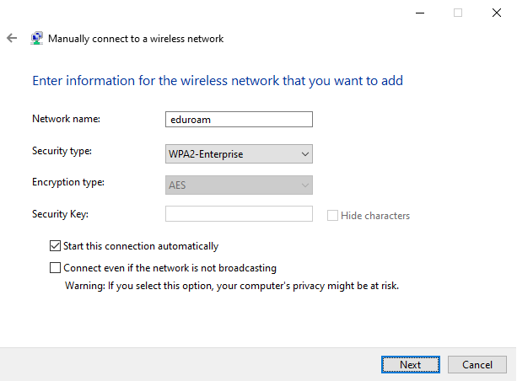

Click Change connection settings
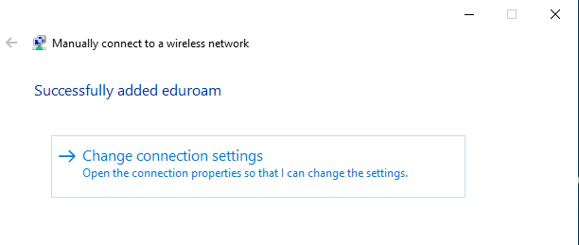
Click on the Security tab, then Settings
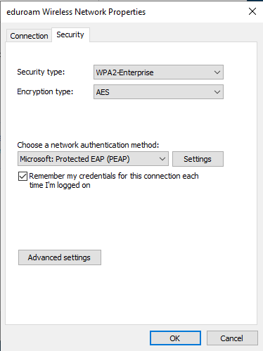
Enter the settings as below:
- Tick the box for Connect to these servers
- Enter radius.gla.ac.uk
- Tick the box next to the AAA Certificate Services
- Click Configure… - ensure option to Automatically use Windows log-on name… is NOT ticked
Select OK, then select OK to return to Network Properties
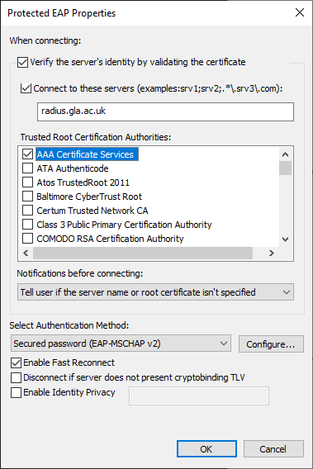

In Network Properties, click Advanced Settings

Click the tick next to Specify authentication mode
Select User authentication from the drop-down menu

Click Save credentials
Enter your full University of Glasgow email address as the username and your password as the password
Note of username format:
- Student: 1234567x@student.gla.ac.uk
- PGR: j.doe.9@research.gla.ac.uk
- Staff: firstname.surname@glasgow.ac.uk
- Affiliate staff (no email):GUID@JRS.glasgow.ac.uk
Select OK in all open windows
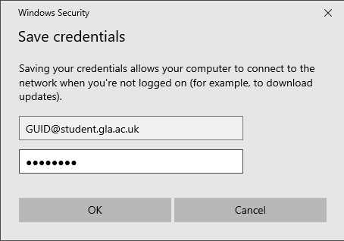
Tip: leave the Successfully added eduroam window open – if the connection fails you can use this to check and correct settings and login details
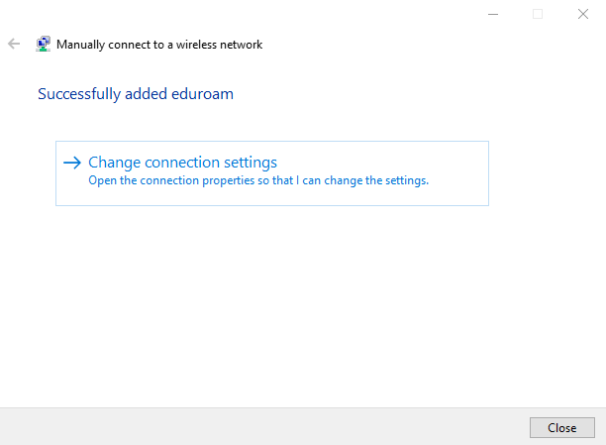
The Network and Sharing Centre should now show an internet connection through eduroam
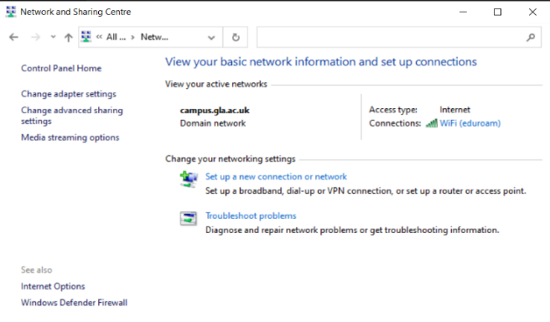
You may have to open your WiFi menu from the system tray (bottom right, next to the time and date) and select eduroam to prompt your computer to start the connection

NEED HELP?
Log an enquiry online using UofG Helpdesk at gla.ac.uk/help
In person: Visit the IT Helpdesk on Level 2. Log in to gla.ac.uk/help then search for “IT Helpdesk Opening hours” or see sign outside the IT Helpdesk.
Phone: 0141 330 4800

